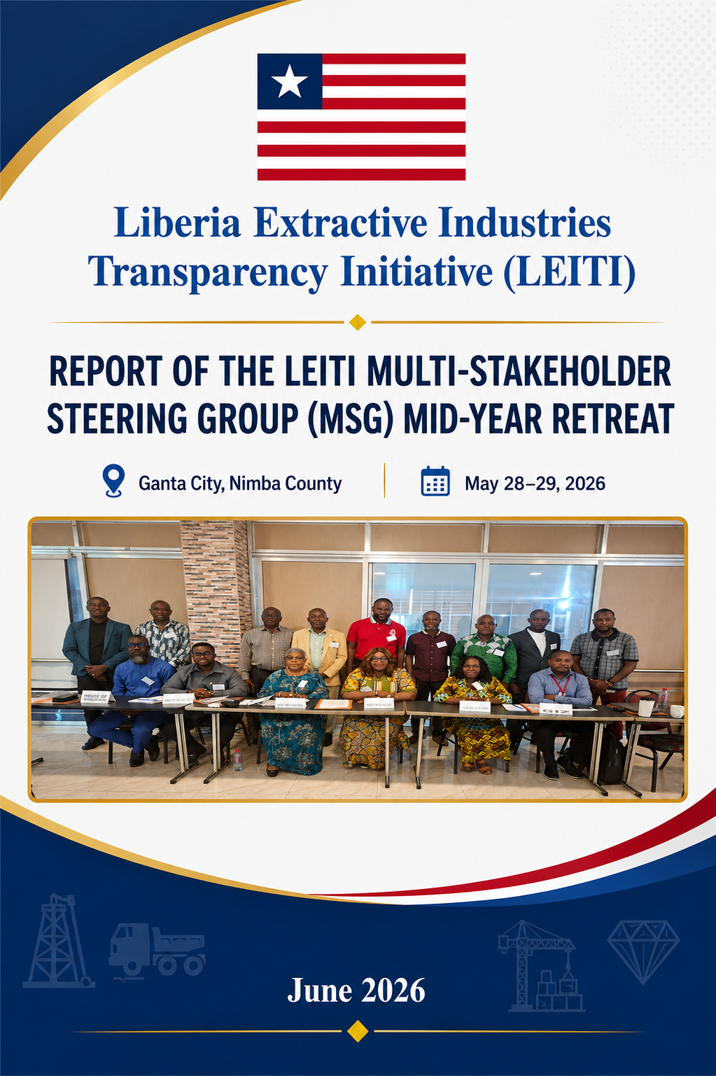
1
1.0 Introduction 5
1.1 Objectives of the Retreat 5
1.1.2 Opening Session 5
2.0 Review of Validation Module 6
2.1 Review and Approval of Draft Validation Response 6
2.1.2 Presentation, Discussion, and Approval of the 16th LEITI Report Summary 7
2.1.3 Presentation and Approval of the 2026 Dissemination Plan 7
2.1.4 Conclusion of Day One 7
3.0 Recap of Day One 8
3.1 Presentation and Approval of PMCS Targets for 2026 8
3.1.1 Presentation of LEITI Data Visualization Samples 8
3.1.2 Review of Progress and Challenges in EITI Implementation 8
3.1.3 Presentation of the MSG Draft Scorecard 9
3.1.4 Update on the EITI Global Conference and HOS EITI Board Election 9
3.1.5 Update on Compliance Investigation 9
3.1.6 Presentation of the PMCS Award to the MSG 9
4.0 Key Decisions and Resolutions 10
5.0 Conclusion 10
6.0 Recommendations 10
7.0 Meeting Attendance 10
8.0 Pictorials from the Meeting 12

Introduction
The Liberia Extractive Industries Transparency Initiative (LEITI) convened a two-day Mid-Year Retreat for members of the Multi-Stakeholder Steering Group (MSG) from May 28–29, 2026, in Ganta City, Nimba County. The retreat brought together representatives from the Government of Liberia, Civil Society Organizations, the Private Sector, and Development Partners to review and approve key institutional documents, assess progress in EITI implementation relative to the approved work plan, and deliberate on priorities for the remainder of the year.
The retreat was organized in accordance with the MSG’s decision from the last retreat in Buchanan, in which they agreed to have a mid-year retreat, and as part of LEITI’s ongoing efforts to strengthen multi-stakeholder engagement, enhance transparency and accountability in the extractive sector, and ensure Liberia’s continued compliance with the EITI Standard.

1.1 Objectives of the Retreat
The objectives of the retreat were to:
- Review and approve key LEITI documents and plans.
- Generate a unified multi-stakeholder response to the International Secretariat’s Draft Validation Report.
- Review progress made in EITI implementation during the first half of 2026.
- Identify challenges affecting implementation.
- Develop recommendations and a way forward to strengthen EITI implementation in Liberia.

1.1.2 Opening Session
The retreat commenced with registration, breakfast, and self-introductions. It was followed by welcome remarks delivered by the proxy (Alternate) of the Chairperson of the LEITI Multi-Stakeholder Steering Group, Deputy Minister Madam Eudora Blay-Pritchard.
The Presiding, Madam Eudora Blay-Pritchard, welcomed her fellow MSG members to the mid-year retreat and emphasized the importance of collective ownership of the EITI process, particularly as Liberia continues to advance transparency and accountability in the management of extractive resources. She reaffirmed the Government of Liberia’s commitment to the EITI principles and Standard.
She highlighted several reforms that have emerged from EITI recommendations, including the integration of beneficial ownership disclosure requirements into the mining licensing process. The deputy minister informed the MSG that the Ministry of Mines and Energy has also advanced the digitalization of mining license applications, introduced new regulatory policies, and strengthened enforcement mechanisms to improve compliance across the sector.
Also making remarks at the retreat was the Deputy Minister of Agriculture for Planning and Research, Mr. David Akoi. He expressed his admiration for the collective approach adopted under the EITI model and commended the LEITI Secretariat for its commitment to implementing the EITI Standard in Liberia. He pledged the Ministry of Agriculture’s continuous support to all transparency initiatives and adherence to the EITI Standard.
Concluding the remarks of the opening session of the retreat was Honorable Sam P. Jallah, Representative of Bomi County District 3, Chairperson of the House of Representatives’ Hydrocarbon Committee, and a member of the MSG representing the House of Representatives. Honorable Jallah described the LEITI as one of the government’s most significant accountability institutions and pledged his continued legislative support for the work of the LEITI. He informed the MSG that the Legislature recognizes LEITI’s critical role in driving reforms within Liberia’s extractive industries. He noted that the Legislature is prepared to strengthen the LEITI’s legal framework by reviewing the LEITI Act and granting the LEITI additional authority to enhance enforcement of the EITI Standard and compliance obligations. He also pledged to ensure that LEITI is allowed to regularly brief the House of Representatives on its activities, progress, and challenges.
The Head of Secretariat of LEITI, Mr. Jeffrey N. Yates, subsequently provided an overview of the retreat, highlighting the objectives, expected outcomes, and key issues requiring the attention of the MSG and subsequent decision by the Body.

DAY ONE PROCEEDINGS

May 28, 2026

2.0 Review of Validation Module
The Head of Secretariat, Mr. Jeffrey N. Yates, led the MSG through a review of the EITI Validation Module, explaining the Validation process and scoring method. He provided an update on Liberia’s Validation process and what the MSG needs to do to improve Liberia’s current score. He said the MSG needs to provide an appropriate response with relevant evidence for Liberia to achieve a score in the “Very Good” range, a jump from the “Moderate Score” achieved in Liberia's last Validation in 2022. The MSG examined the Validation assessment framework and provided their perspectives. The MSG agreed that since the last validation, Liberia has made significant progress and deserves to be graded “Very Good”.

2.1 Review and Approval of Draft Validation Response
The Head of Secretariat presented the draft Validation Report to the MSG for their review. Having reviewed the draft Validation Report, the MSG members discussed its observations and recommendations and collaboratively developed a unified response that reflects the views of all MSG constituencies.
Following detailed deliberations, the MSG approved the draft validation response with agreed amendments for subsequent submission to the International Secretariat’s Validation Team.
The MSG, however, deferred its final decision on “project-level reporting” until the next day, following consultations with relevant authorities on the applicability of this requirement in Liberia.

2.1.2 Presentation, Discussion, and Approval of the 16th LEITI Report Summary
The Head of Secretariat presented the summary of the 16th EITI Report, highlighting major findings, revenue disclosures, and key trends in Liberia’s extractive sector.
The MSG discussed the report’s findings, structure, and their implications for transparency and public accountability. The MSG subsequently approved the summary for dissemination and stakeholder engagement activities.

2.1.3 Presentation and Approval of the 2026 Dissemination Plan
The Head of Secretariat presented the LEITI 2026 Dissemination Plan, outlining strategies for communicating EITI findings to stakeholders across Liberia. The plan provided the months planned for dissemination, the counties to be covered, and the teams’ composition.
The MSG reviewed the proposed Dissemination Plan and emphasized the importance of expanding outreach to local communities, civil society organizations, and the media. The MSG requested that the counties be grouped into “regions 1, 2, and 3” rather than by compass direction. Following discussions, the 2026 Dissemination Plan was approved by the MSG.

2.1.4 Conclusion of Day One

Day one of the mid-year retreat concluded with the following achievements:
- A clear Understanding of the new EITI Validation Model by the MSG
- A consensus among MSG members that Liberia deserves “Very Good” in EITI implementation, given the achievements so far.
- A complete review of the draft Validation Report
- A review and approval of the draft response to the draft Validation Report, with the proviso that “project-level reporting” will be finalized the next day.
- A review and approval of the 16th Report summary
- A review and approval of the LEITI 2026 Dissemination Plan

DAY TWO PROCEEDINGS

May 29, 2026

3.0 Recap of Day One
The second day of the retreat began with a recap of the previous day’s discussions and decisions by the Head of the Secretariat. The recap provided the MSG with an opportunity to reflect on key issues discussed the previous day and prepare for the remaining agenda items.

3.1 Presentation and Approval of PMCS Targets for 2026
Mr. Jeffrey N. Yates presented the LEITI Secretariat Performance Management and Compliance System (PMCS) targets for 2026 to the MSG for their review and approval. The MSG reviewed the proposed targets, their SMART nature, and discussed their alignment with LEITI’s strategic objectives. Following deliberations, the MSG approved the PMCS targets for implementation during the year.

3.1.1 Presentation of LEITI Data Visualization Samples
In an attempt to make Liberia’s EITI data more useful and meaningful to the public, the LEITI Secretariat has embarked on a data visualization exercise using key aspects of the 16th EITI Report and the LEITI Updated Simplified Contract Matrix. This is intended to highlight the key findings using data analysis and visualization techniques to facilitate easy public understanding.
During the MSG retreat, the LEITI Secretariat showcased sample data visualization products designed to enhance public understanding of information on the extractive sector.
MSG members welcomed the initiative and noted the potential of visual tools to improve accessibility and stakeholder engagement. Suggestions were made for further refinement and wider dissemination.

3.1.2 Review of Progress and Challenges in EITI Implementation
The Head of Secretariat presented an update on progress made in implementing EITI activities in Liberia during 2026.
Key achievements were highlighted alongside implementation challenges, including resource constraints and the ability of reporting institutions to meet timelines. The MSG discussed strategies to address identified challenges and improve overall implementation of the EITI this year.

3.1.3 Presentation of the MSG Draft Scorecard

The Head of Secretariat presented the MSG’s draft scorecard, indicating where each institution stands regarding the attendance of the principal, alternate, and others. The scorecard awards 25 points to the principal, 20 to the alternate, and 15 to the other. The scorecard showed some institutions with high performance and others with low performance based on the individual attending.

3.1.4 Update on the EITI Global Conference and HOS EITI Board Election
The Head of Secretariat informed the MSG that the postponed EITI Global Conference has now been rescheduled for October 8-9, 2026, in Brussels, Belgium. He expressed concerns regarding obtaining a Schengen Visa in Liberia as opposed to the Philippines, which is visa-free. The Body was, however, informed by Mr. James M. Strother that a French Visa can be obtained in Liberia and be used to enter Belgium.
The Head of Secretariat also informed the MSG of his nomination for election to the EITI Board to represent the Anglophone and Lusophone region. The MSG applauded the HOS, expressed confidence that he would be elected, and wished him well in his endeavor to represent the region.

3.1.5 Update on Compliance Investigation

The Head of Secretariat provided an update on the Compliance Investigation approved by the MSG last year. He informed the MSG that the consultant conducting the investigation was finalizing the report and had received a response from ArcelorMittal, which was delaying completion.

3.1.6 Presentation of the PMCS Award to the MSG
The retreat concluded with the presentation in absentia of the PMCS Award to the MSG in recognition of LEITI's excellent performance during the 2025 PMCS cycle. The MSG commended the Secretariat for its hard work and approved US$50.00 for each staff member as appreciation for their efforts so far. They also discussed staff low salaries and how they can work with the Ministry of Finance and Development Planning to ensure that LEITI is upgraded to the salary level of other integrity institutions in the country. The Body also approved awarding a 13-month bonus to staff, if available, as a sign of appreciation for their work.

4.0 Key Decisions and Resolutions
The MSG:
- Approved the Draft Validation Response for submission to the EITI International Secretariat.
- Approved the Summary of the 16th LEITI Report.
- Approved the LEITI 2026 Dissemination Plan.
- Approved the PMCS Targets for 2026.
- Endorsed continued development and use of data visualization tools.
- Endorsed the MSG mid-year scorecard
- Reaffirmed its commitment to addressing implementation challenges and strengthening EITI compliance.
- Approved US$50.00 for all LEITI staff as an appreciation for their hard work. The need for a 13-month payment to staff was also approved.
- A staff benefit arrangement of USD 150.00 will be provided to all staff for July 2026
- Authorized the Secretariat to do an assessment in Bomi and Cape Mount for the next MSG retreat in November 2026.

5.0 Conclusion
The two-day Mid-Year Retreat provided an important platform for strategic reflection, decision-making, and consensus-building among members of the LEITI Multi-Stakeholder Steering Group. The retreat achieved its objectives by facilitating the review and approval of key documents and strengthening preparations for the Secretariat's upcoming activities.

6.0 Recommendations
- Next retreat should include sightseeing at mining projects
- The next retreat should include time for debate on issues by MSG members
- The LEITI Secretariat should share the retreat agenda before the retreat
- Those representing constituencies should provide a report from their constituencies
- Documents to be approved by the MSG should be provided days before the retreat.

7.0 Meeting Attendance
No. | Name of MSG Member/Alternate |  | Institution | Contact
1. | Eudora Blay- Pritchard |  | Ministry of Mines & Energy (MME) | 0777519100
2. | Emmanuel Azango |  | National Oil Company of Liberia (NOCAL) | 0886870477
3. | Sam P. Jallah |  | House of Representatives (HOR) | 0777077080
4. | David K. Akoi |  | Ministry of Agriculture (MOA) | 0770408157
5. | Cllr. J. Alben Greaves |  | Ministry of Justice (MOJ) | 0776469524
6. | Prince P. Nelson |  | Ministry of Finance and Development Planning (MFDP) | -------
7. | N. Rufus Scott |  | Liberia Petroleum Regulatory Authority (LPRA) | 0776465053
8. | Emmanuel E. A. Witherspoon II |  | Liberia Revenue Authority (LRA) | 0886457090
9. | Cecelia T. Danuweli |  | Publish What You Pay Liberia Coalition (PWYP-Liberia) | 0886572696
10. | Winston W. Wreh |  | Liberia Labor Congress (LLC) | 0776147982
11. | Amb. George N. Kingsley |  | National Civil Society Council of Liberia (NCSCL) | 0886601991
12. | James M. Strother |  | Liberia Business Association (LIBA) | 0775843067
13. | Abraham B. Gappie |  | Mineral Civil Society Organizations of Liberia (MICSOL) | 0555771912
14. | Eliza D. K. Kronyanh |  | Liberia Timber Association (LibTA) | 0770421704
15. | Cllr. Michael V. Suah |  | Liberia Chamber of Mines | 0777518443
16. | Elvis G. Morris |  | Liberia Agriculture Company Association (LACA) | 0886424335
17. | Djomba MARA |  | GIZ | 0775236167
LEITI Secretariat Staff
1. | Jeffrey N. Yates |  | LEITI Secretariat | 0770167440
2. | Zaza Y. Quaqua |  | LEITI Secretariat | 0777060350
3. | George N. Dennis |  | LEITI Secretariat | 0770426847
4. | McDonald S. Kerl, Sr. |  | LEITI Secretariat | 0886492515
5. | Saba B. Cephas |  | LEITI Secretariat | 0886548315
6. | Christine Humaru |  | LEITI Secretariat | 0770187196
7. | Reuben Freeman |  | LEITI Secretariat | 0776557728

8.0 Pictorials from the Retreat

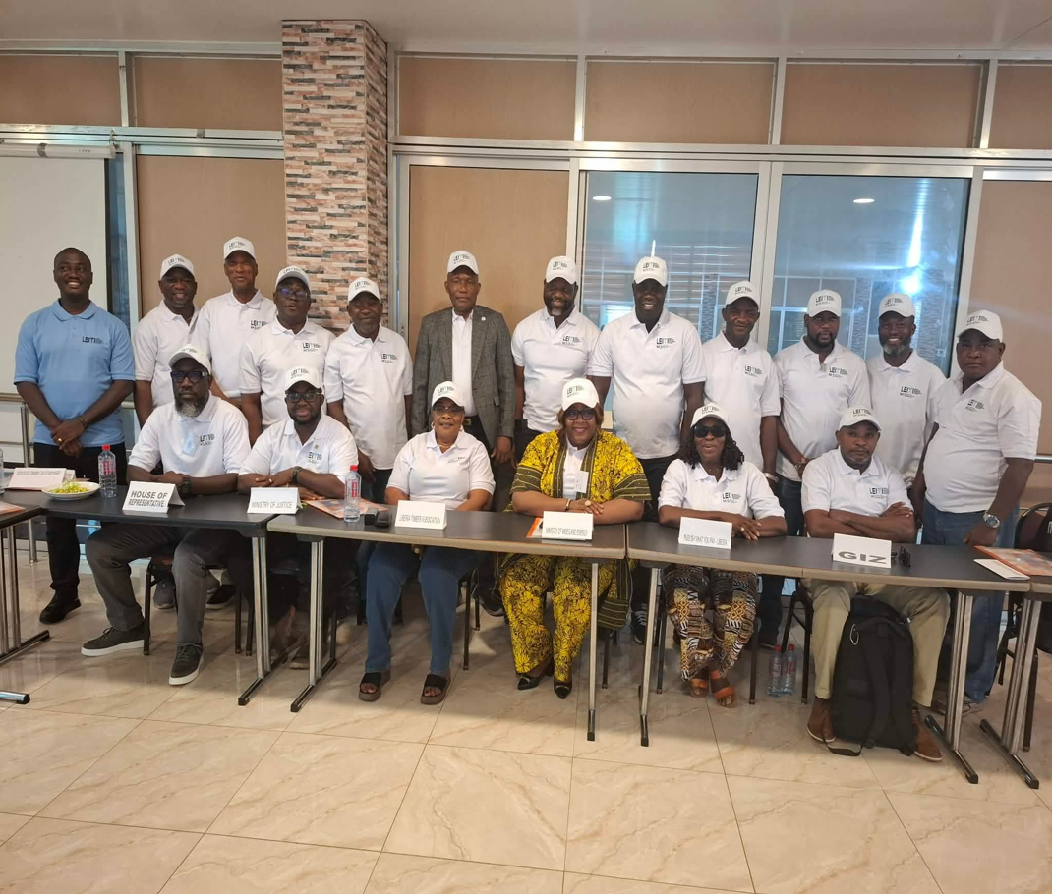
MSG group photo on day two of the retreat.

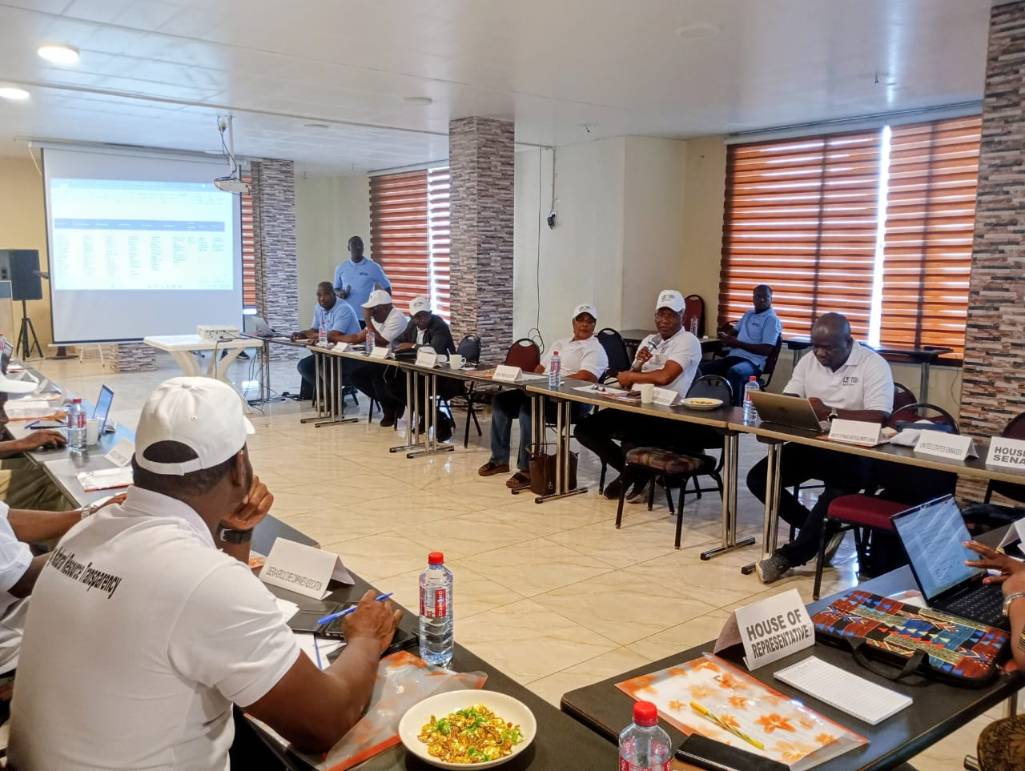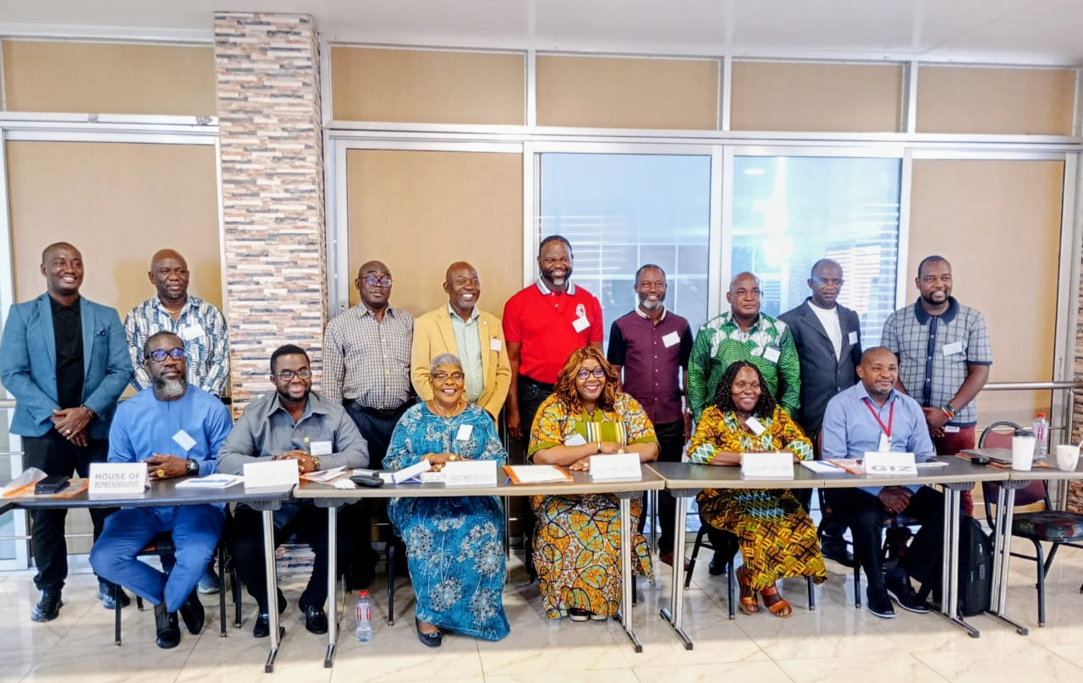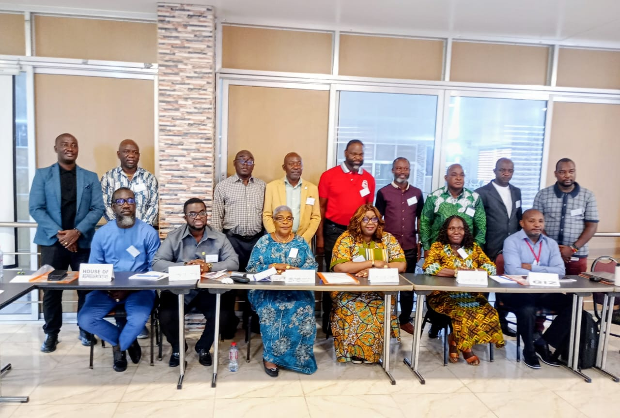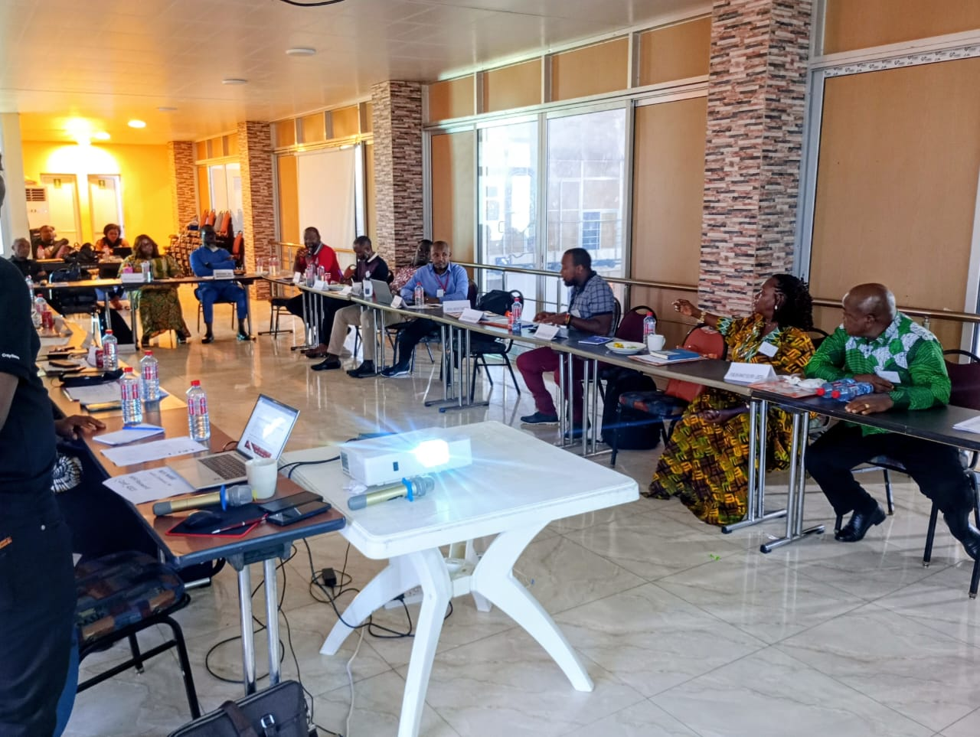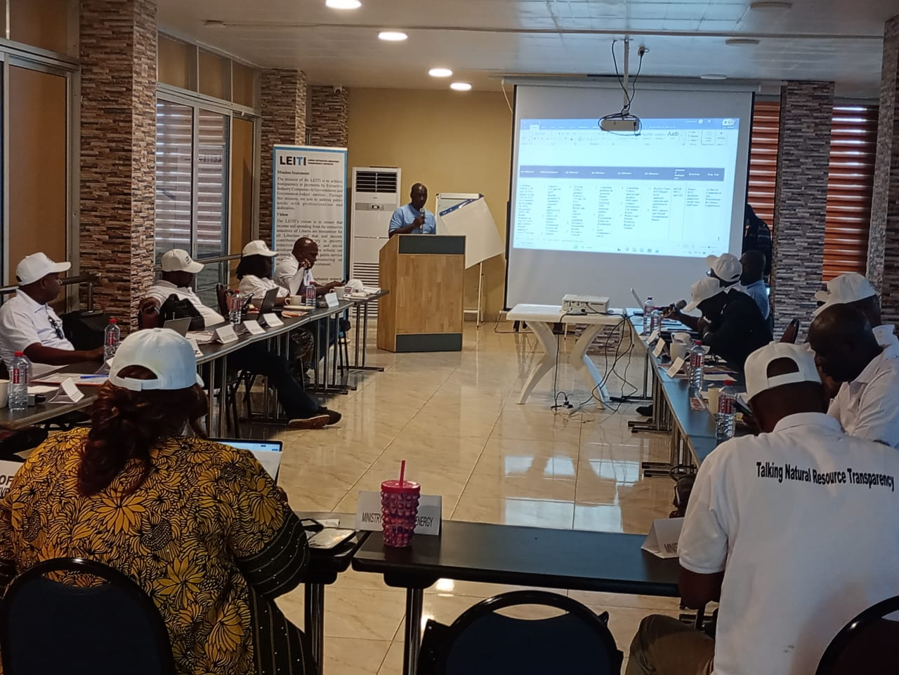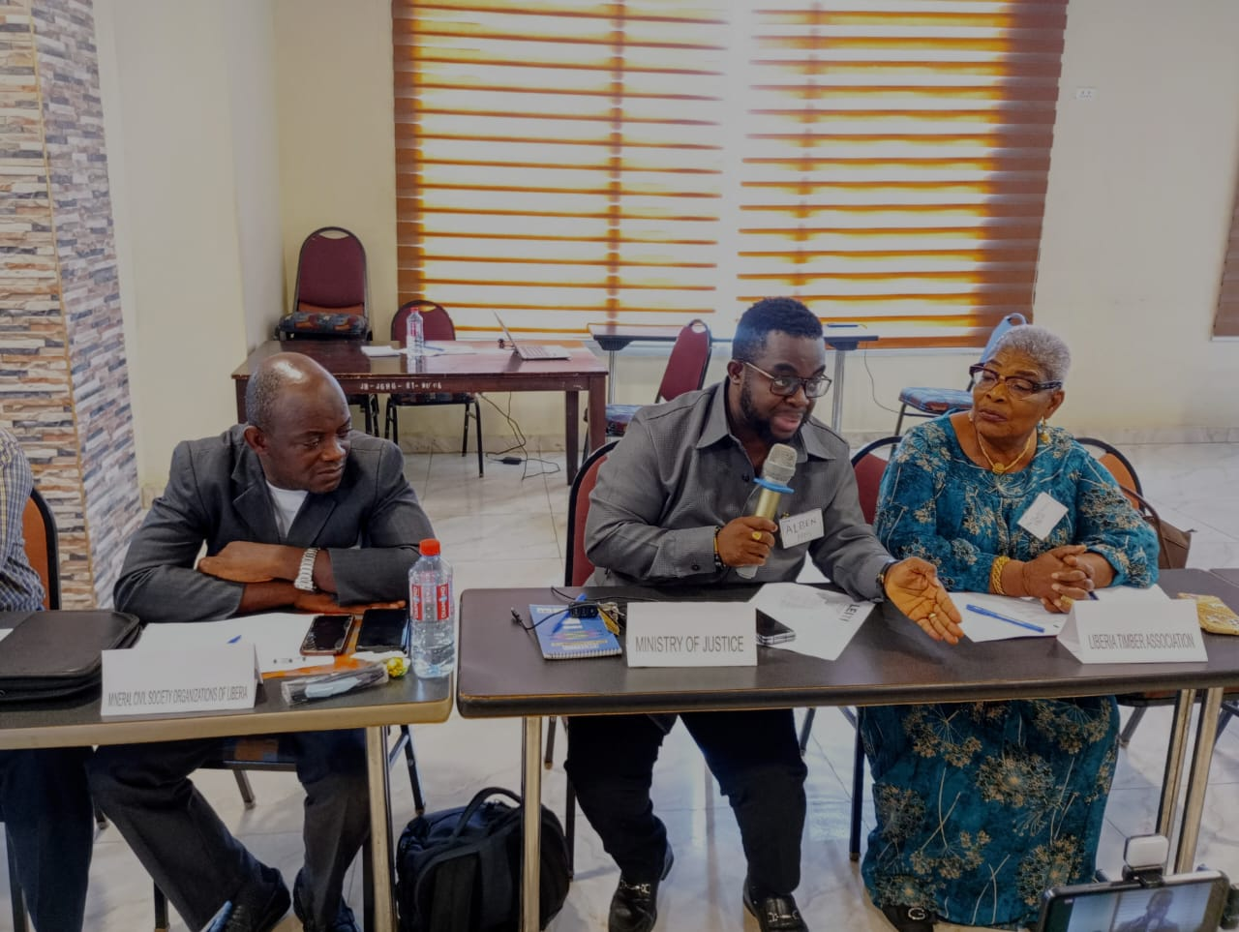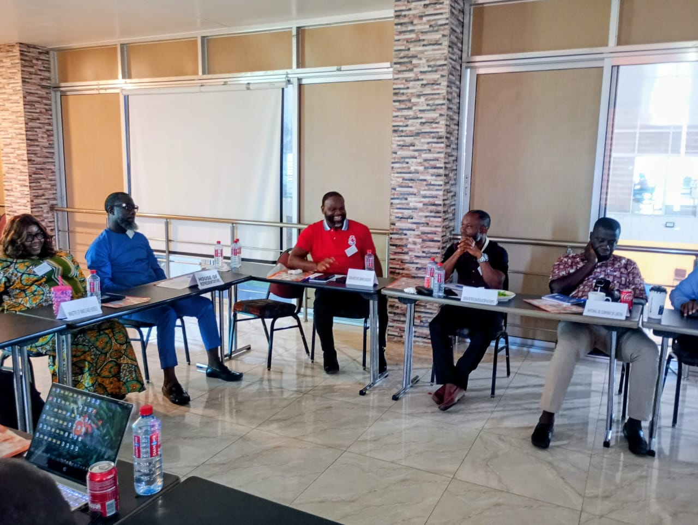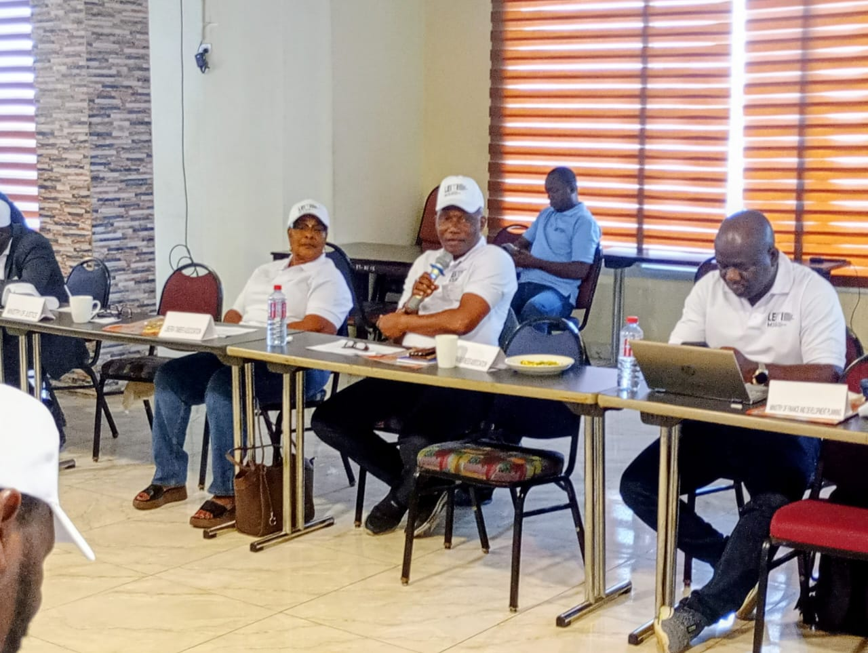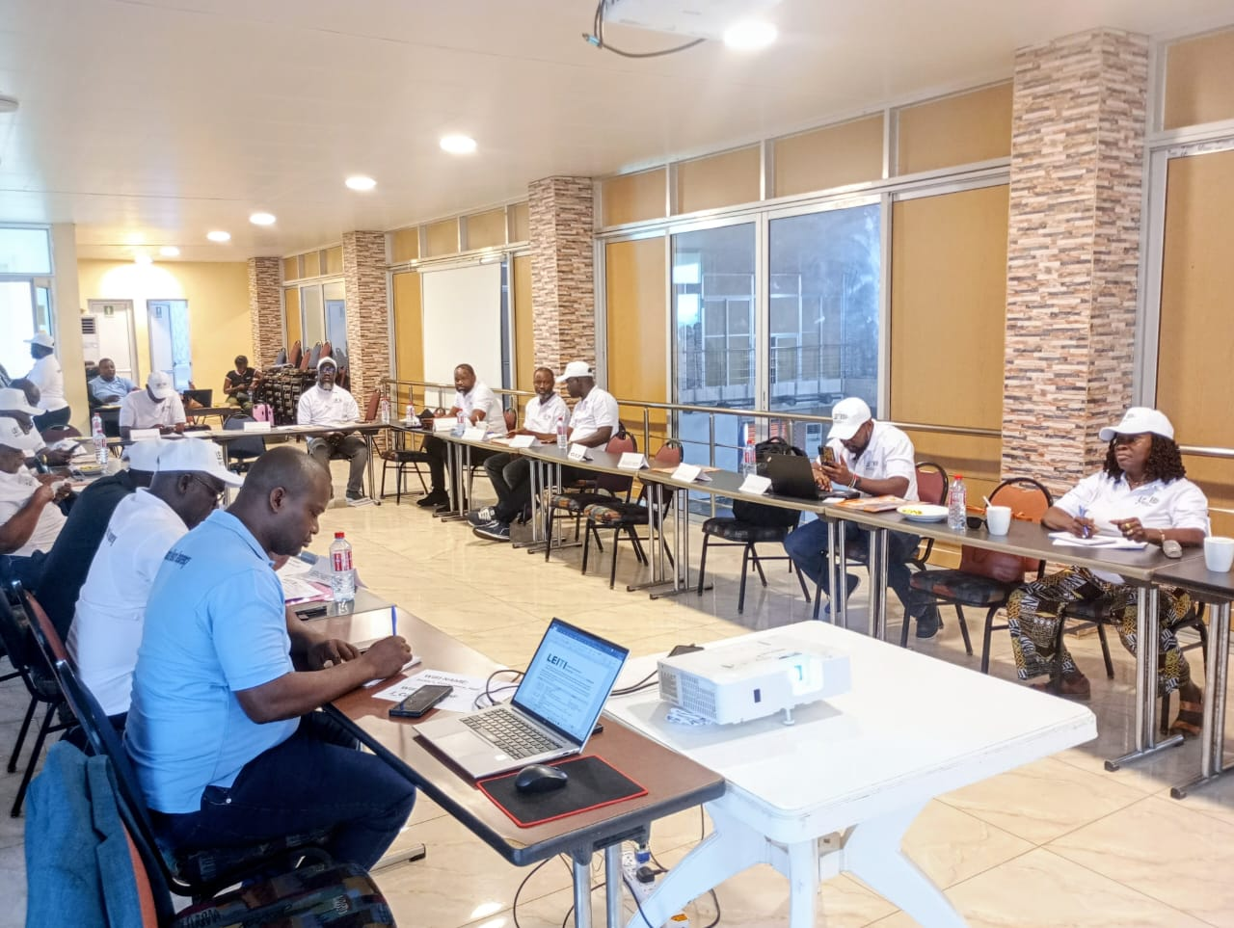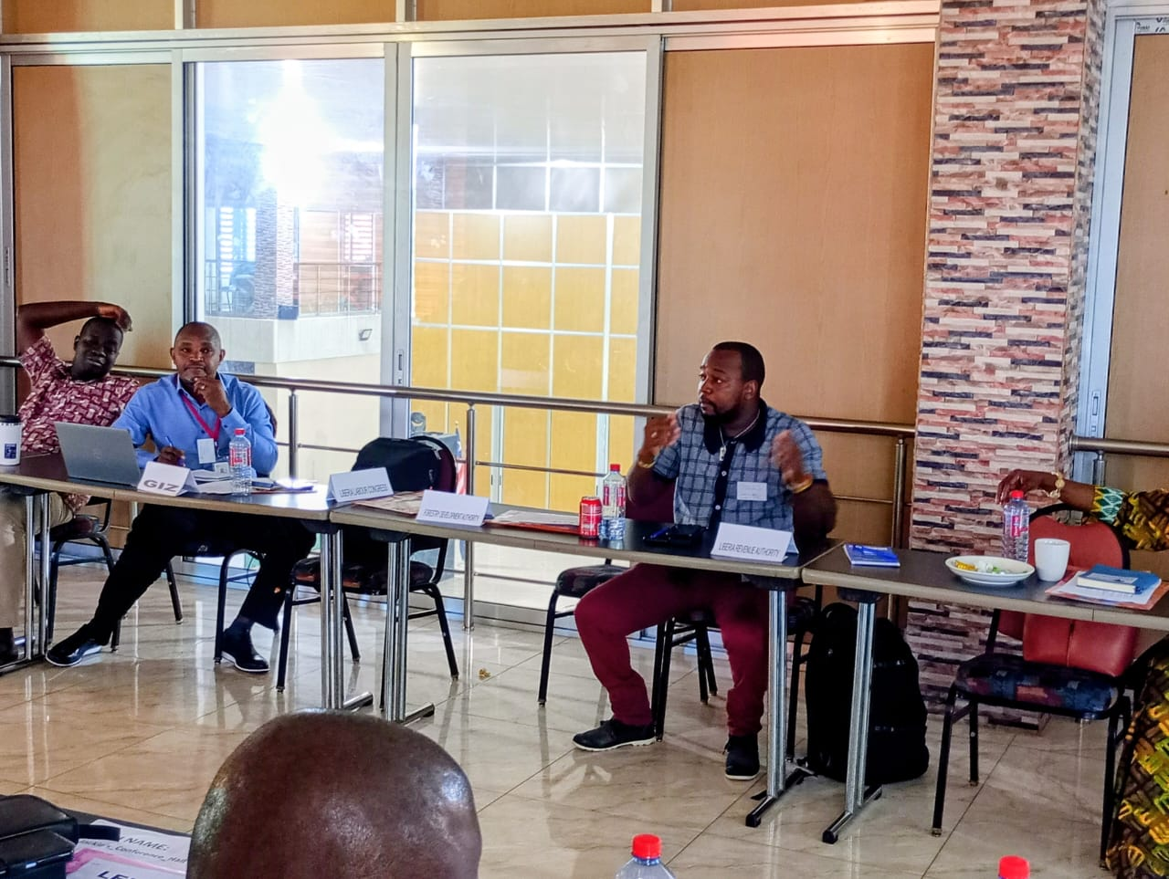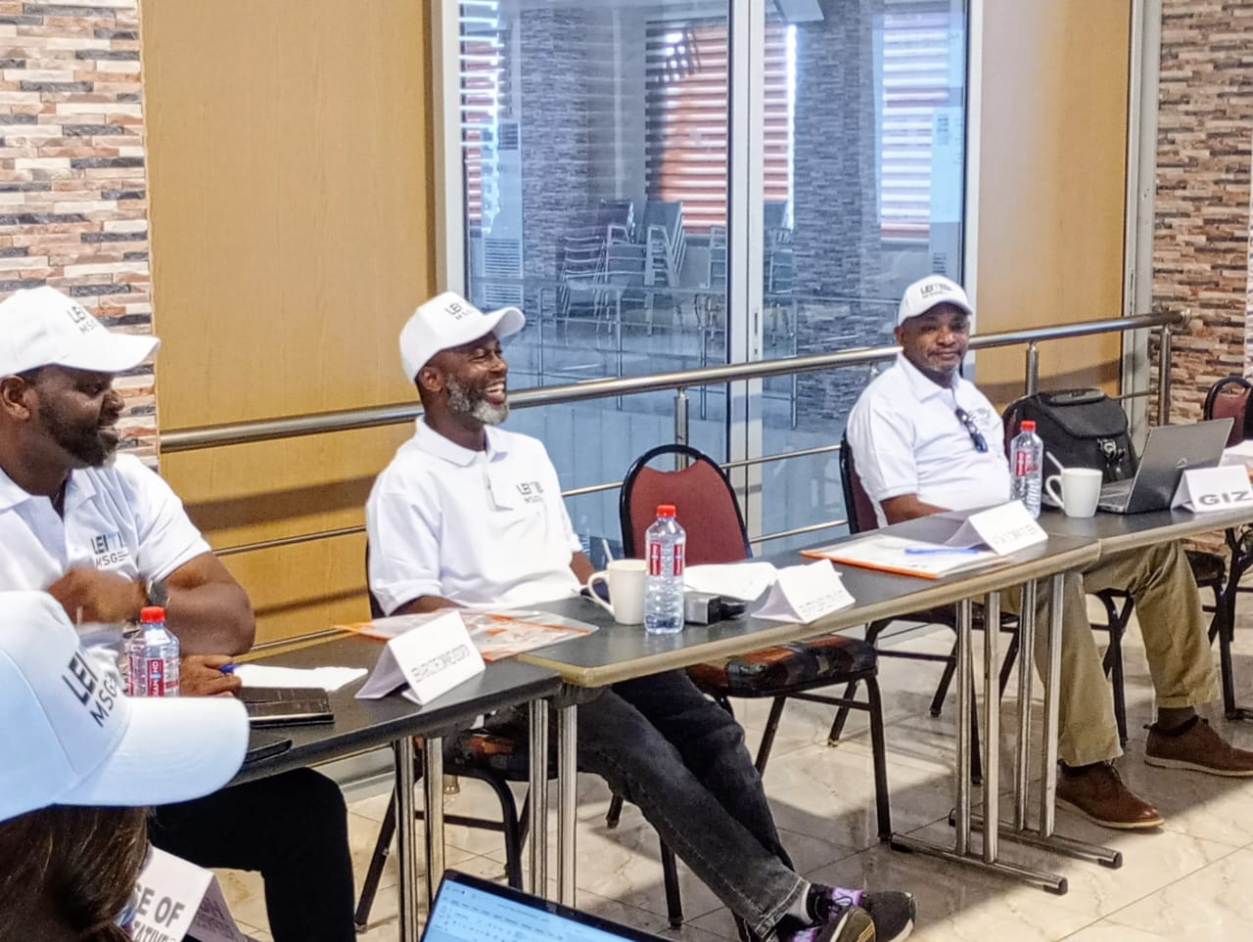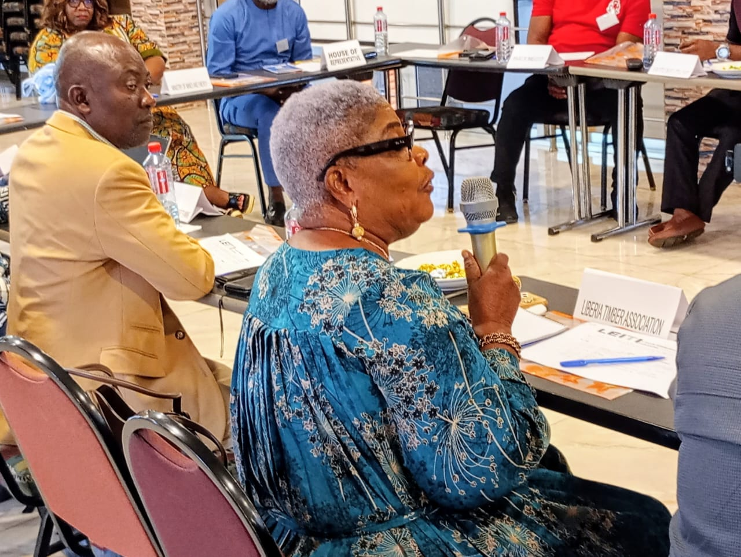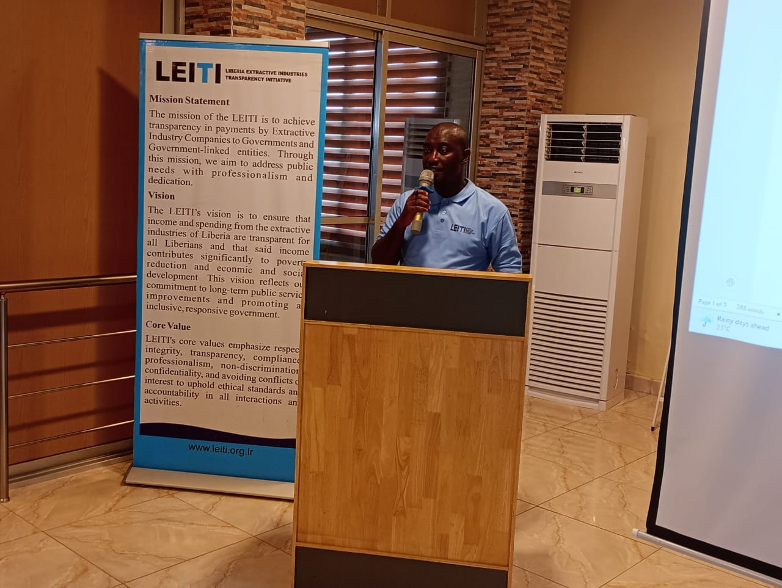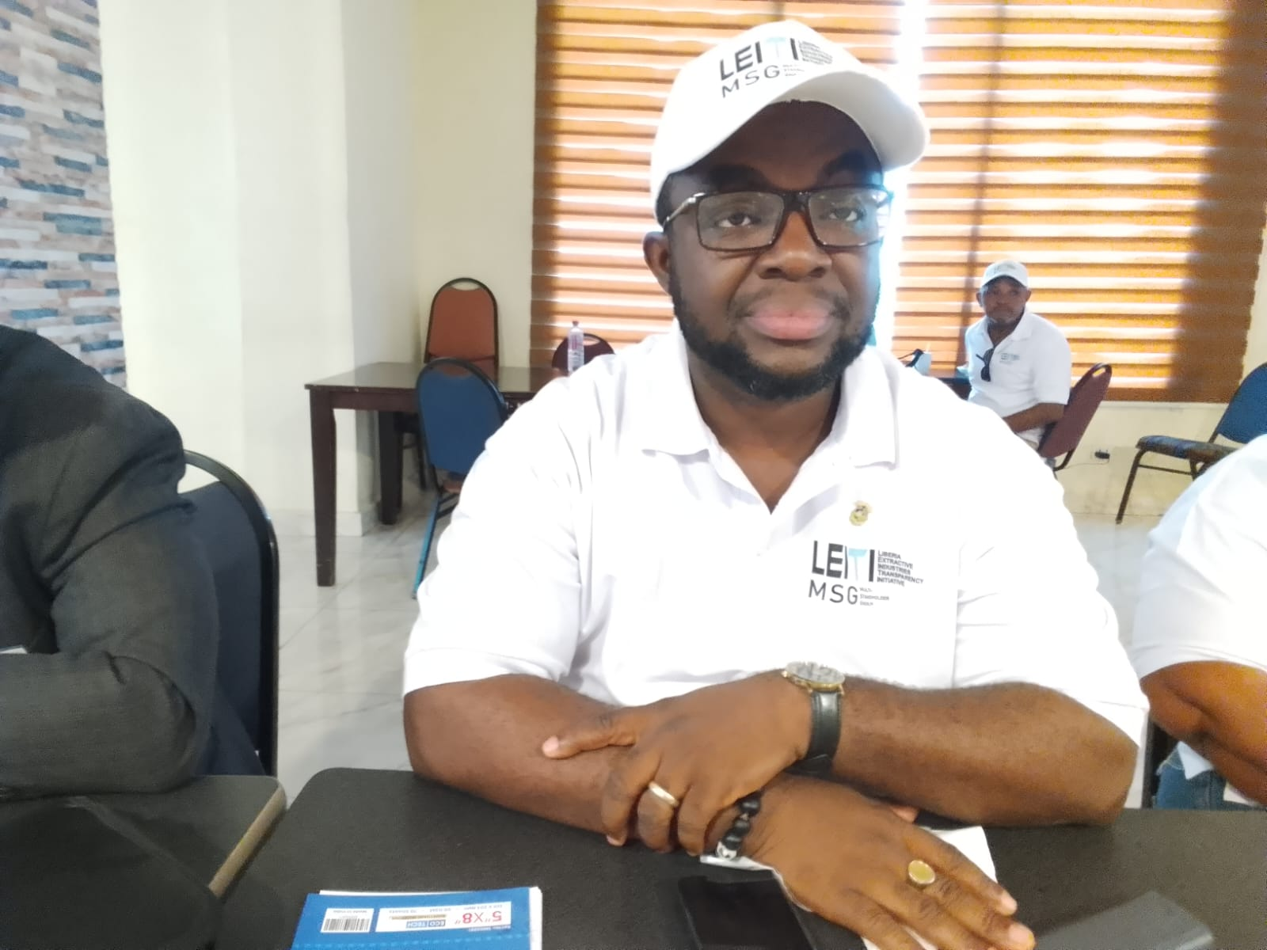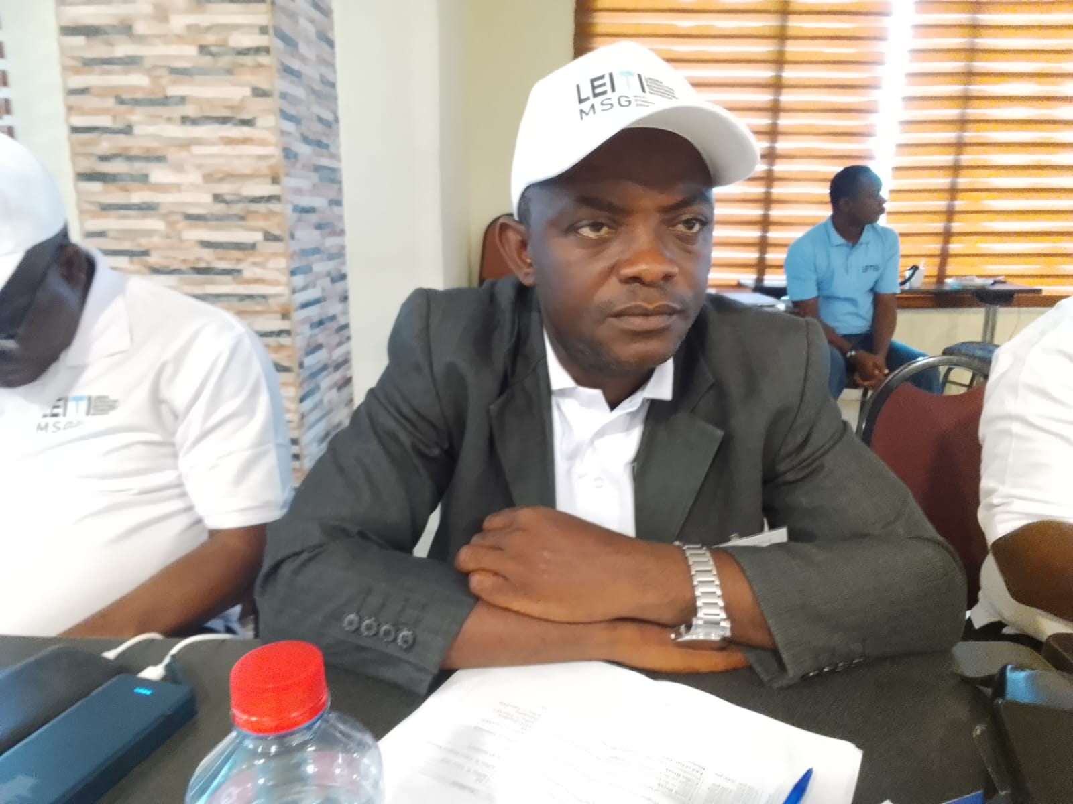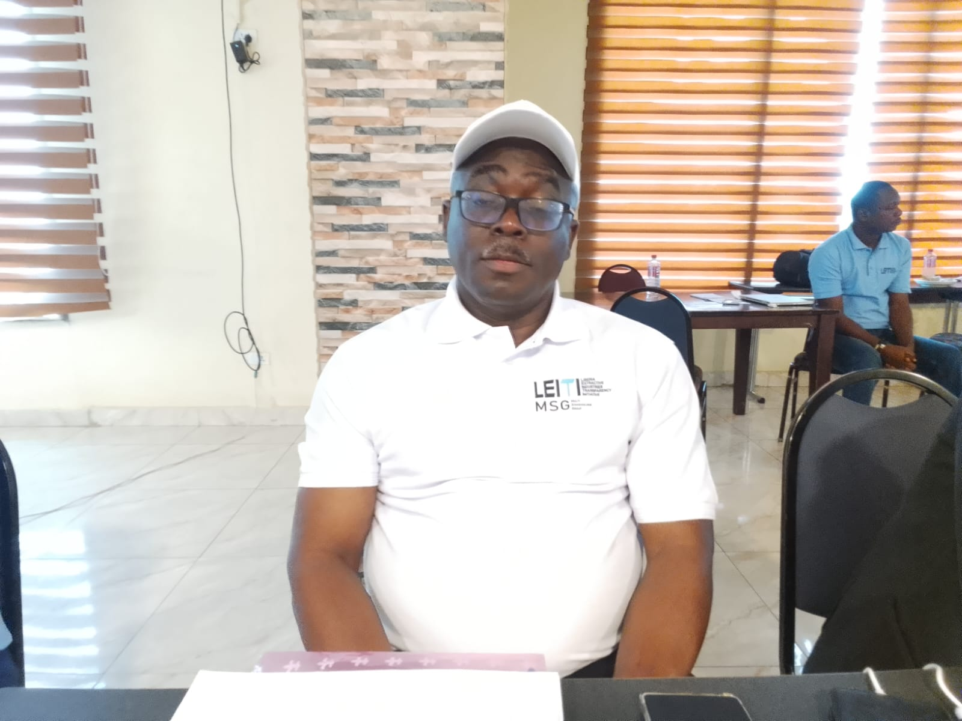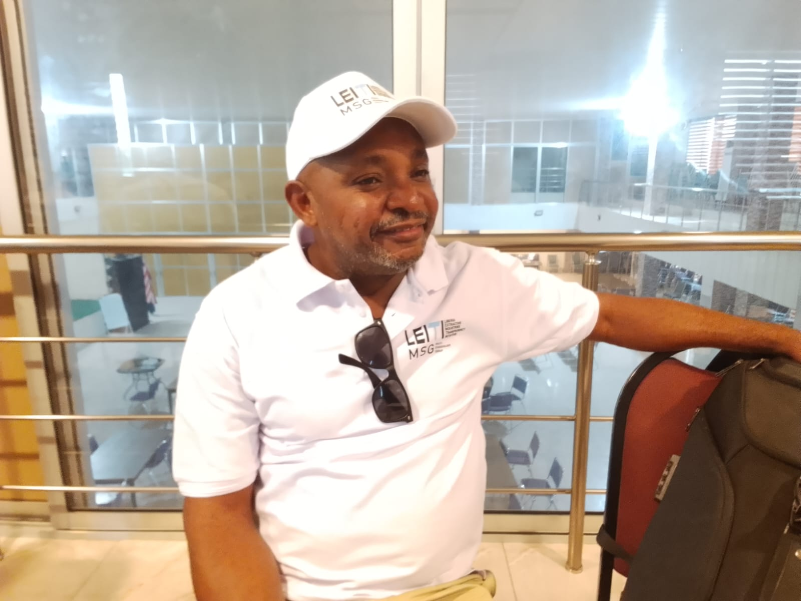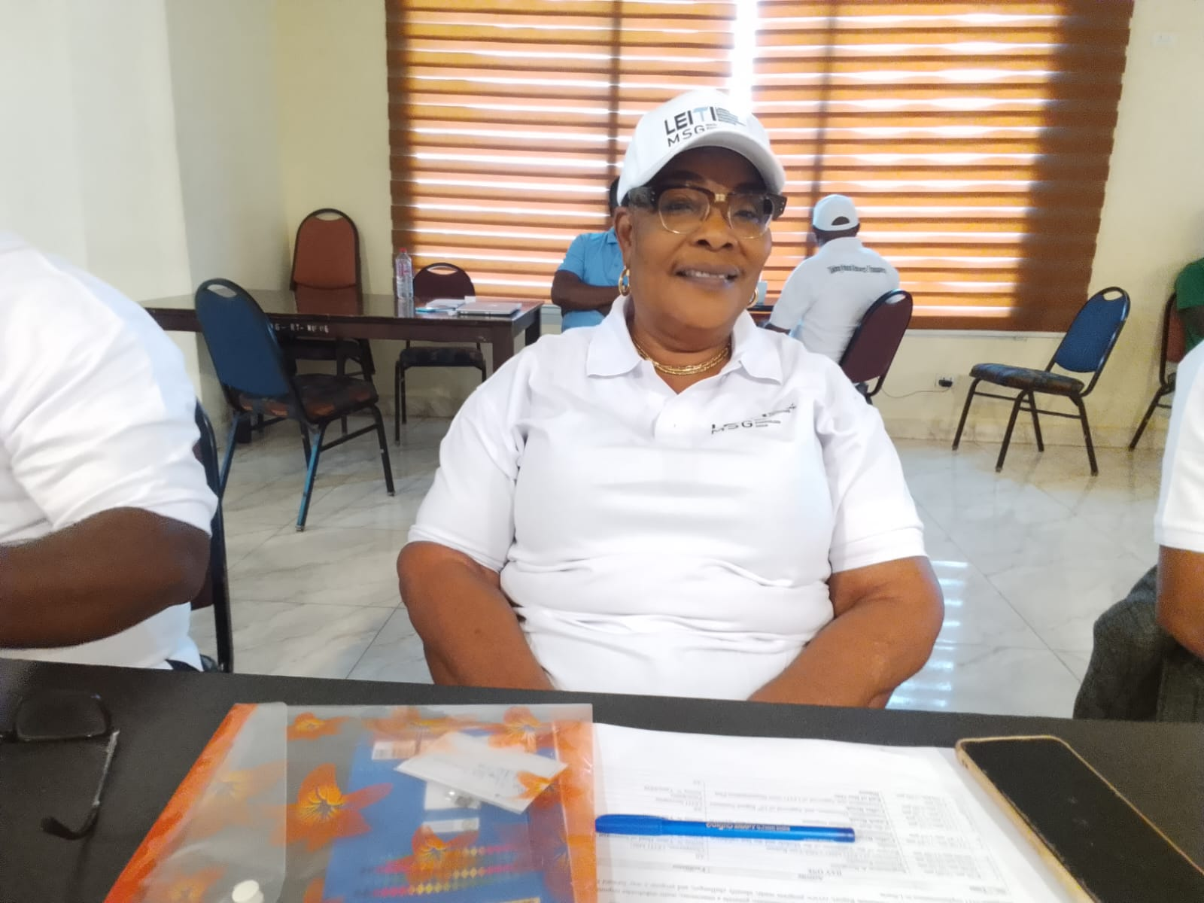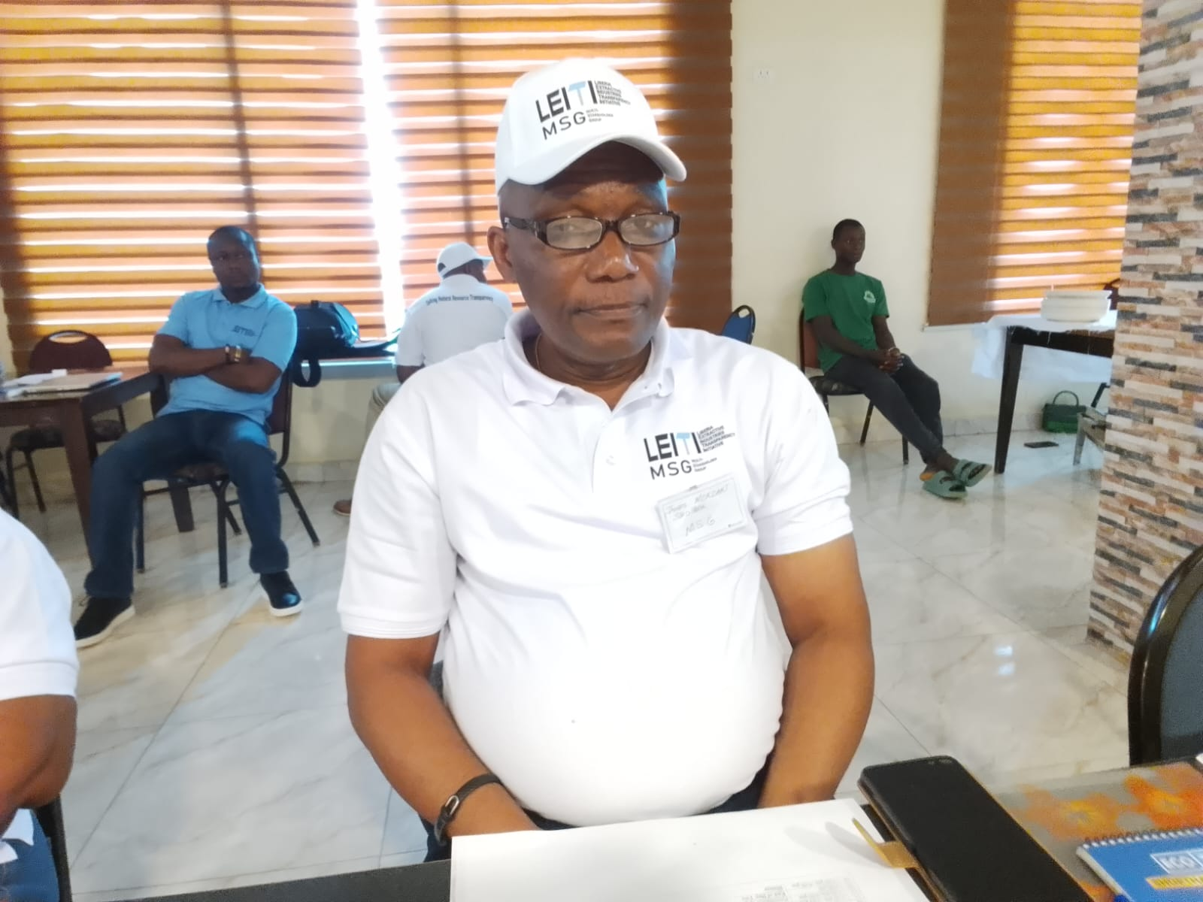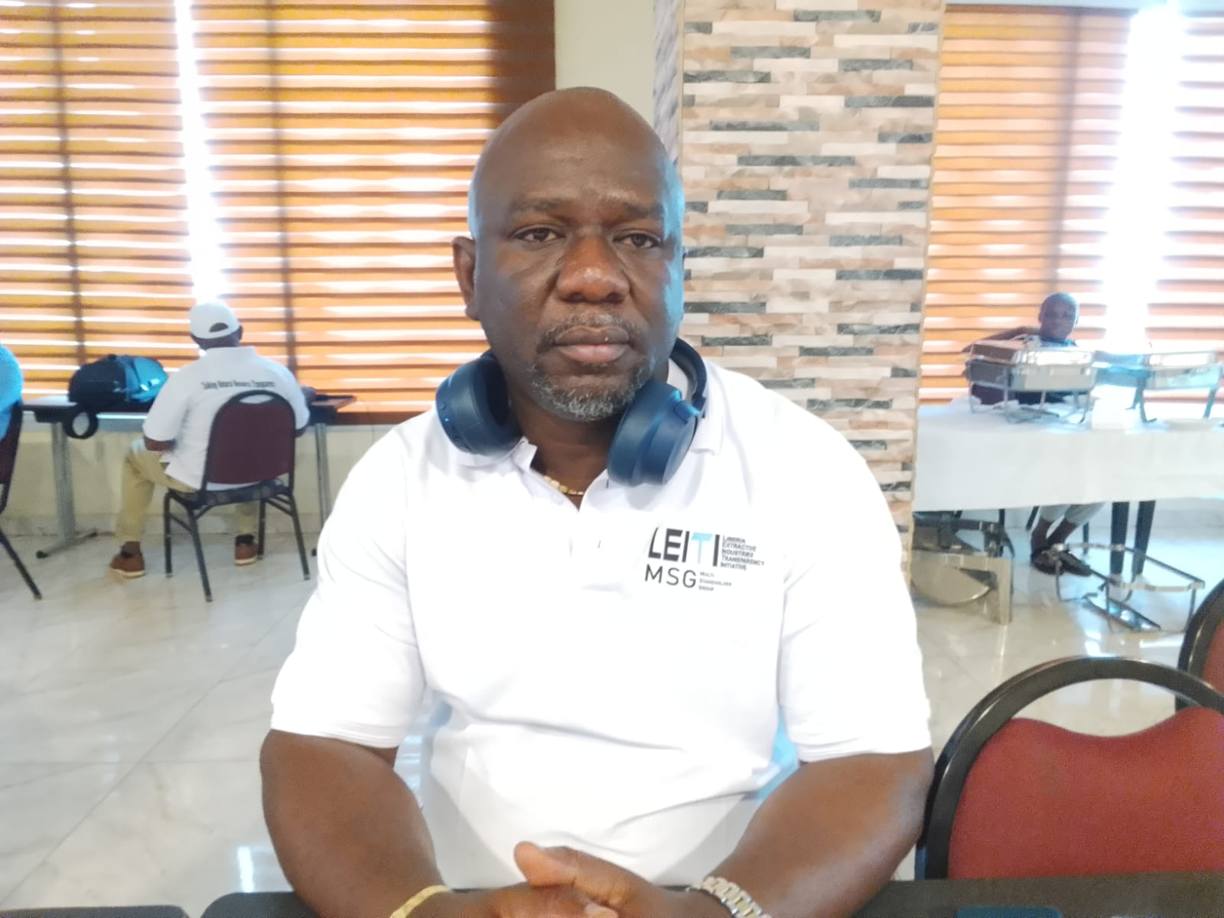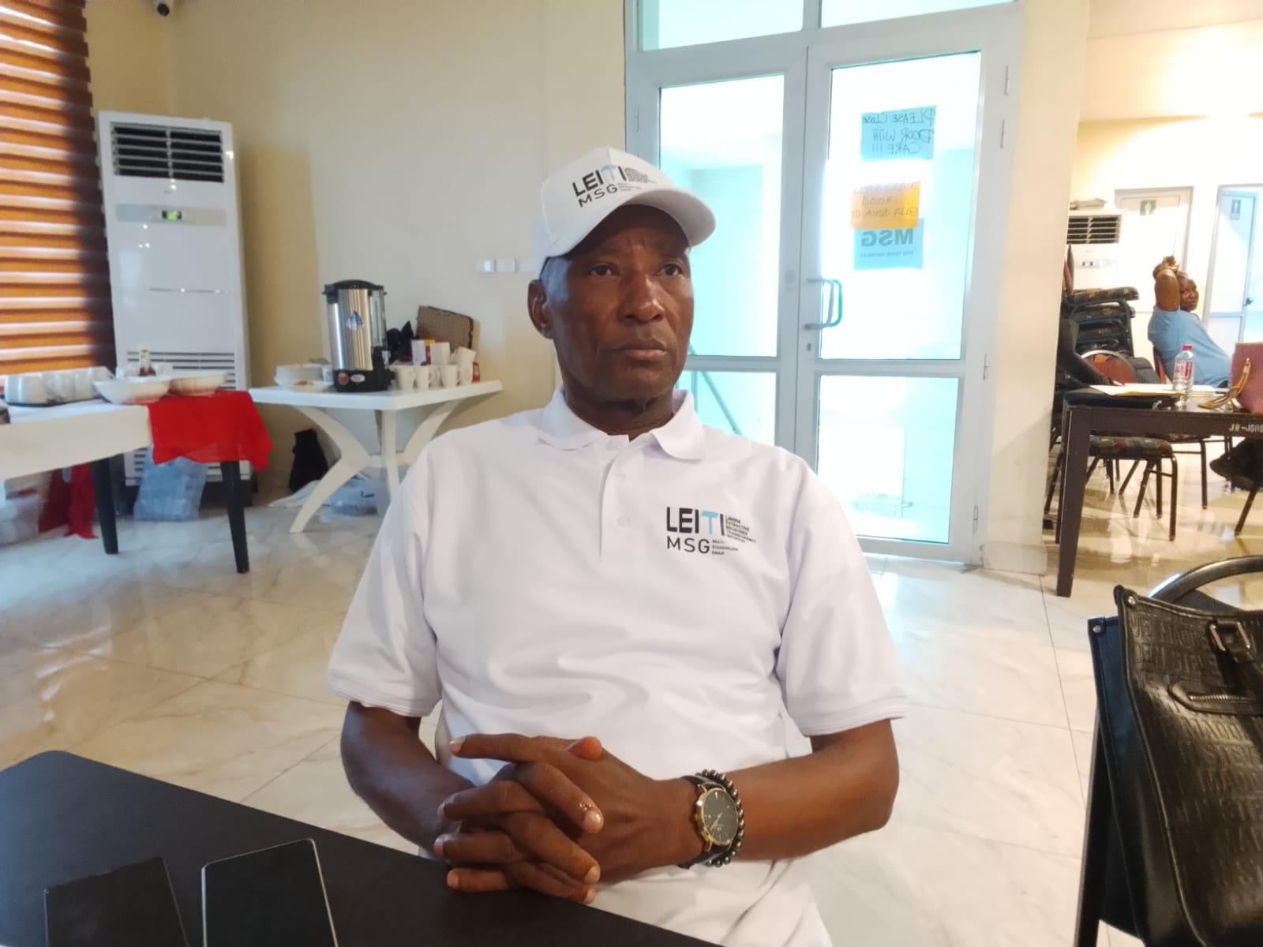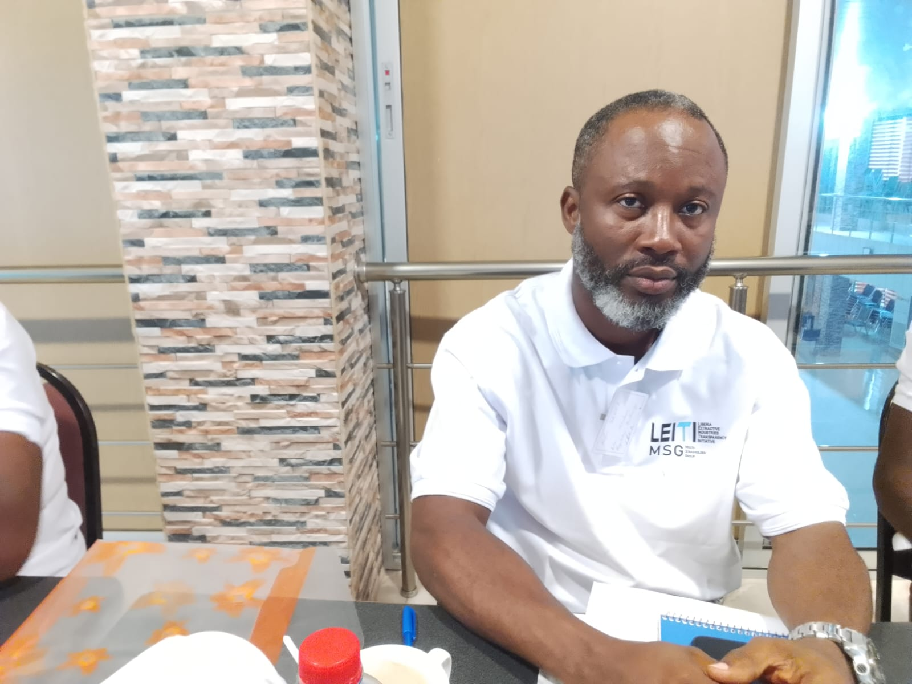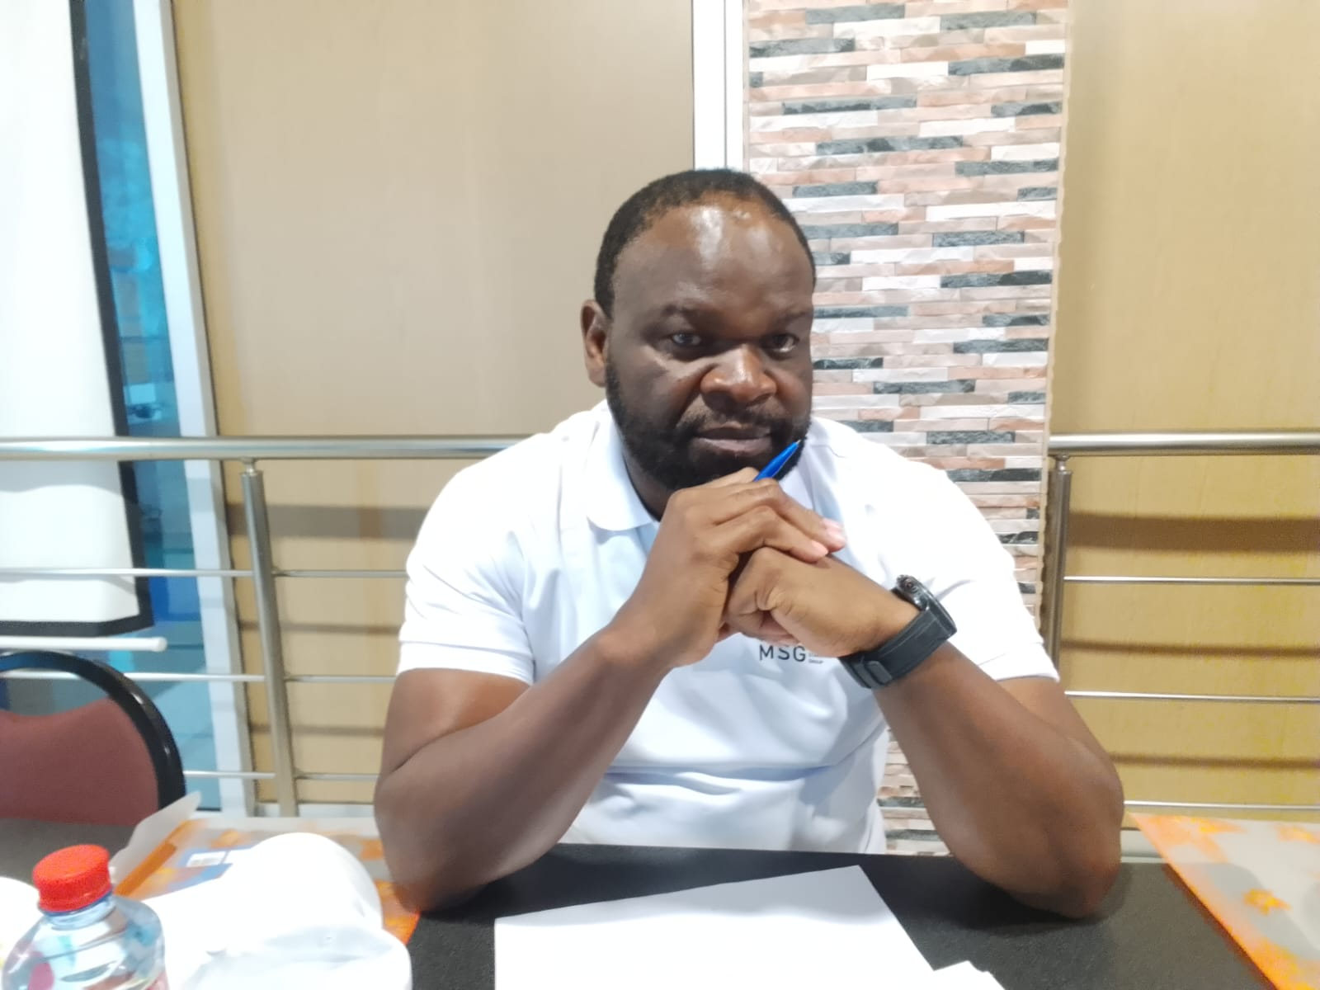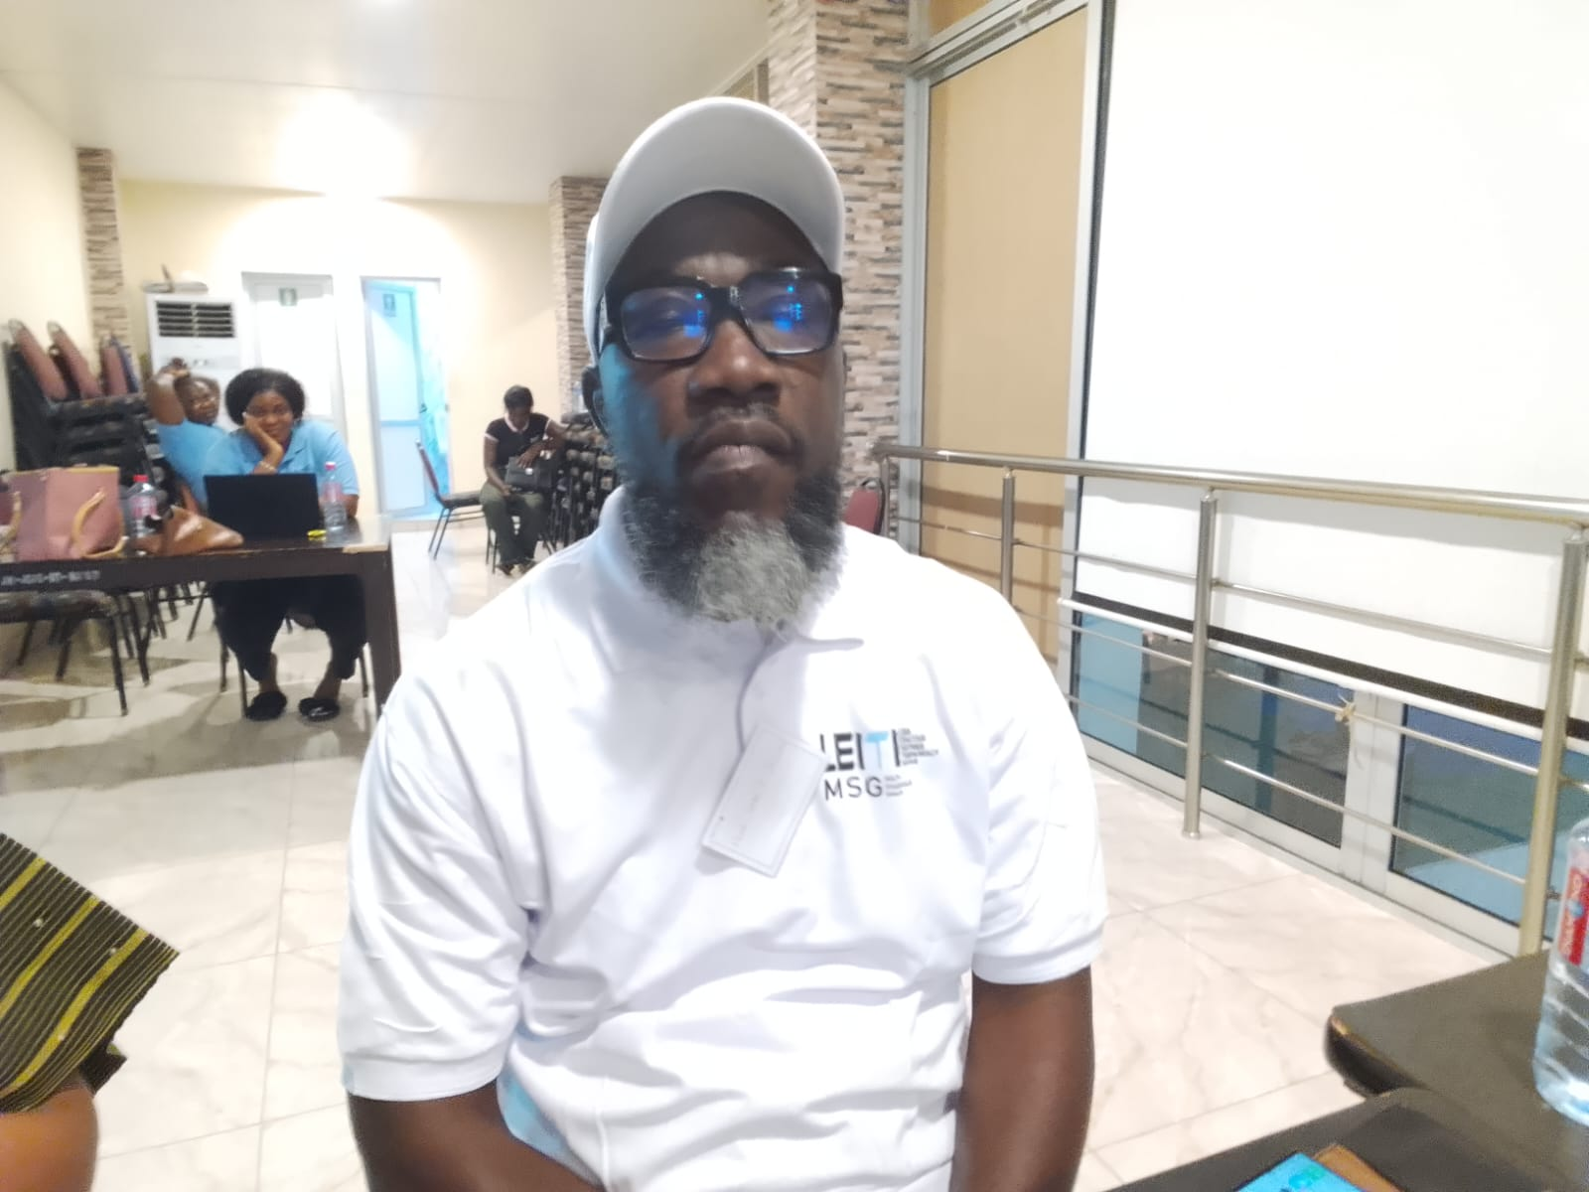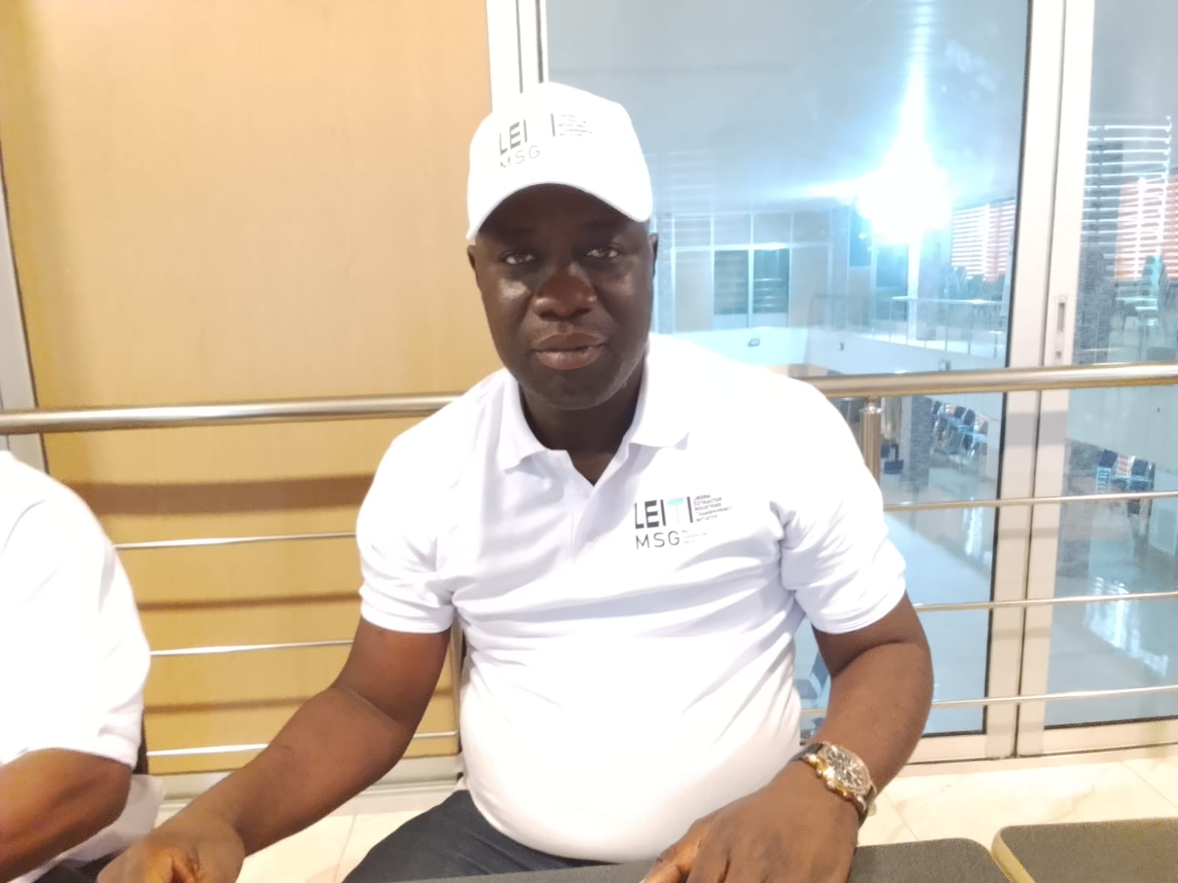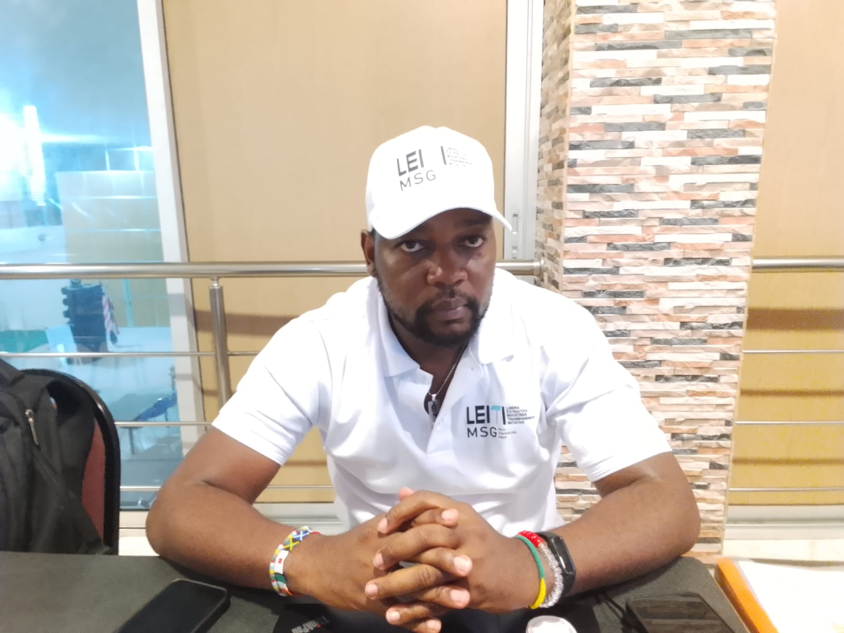
A discussion session on day two of the MSG retreat.
MSG group photo on day one of the retreat.

MSG group photo on day one of the retreat.
A panoramic view of the MSG session during day one of the retreat.

LEITI’s Head of Secretariat, Jeffrey N. Yates, presents LEITI’s PMCS targets to the MSG for review and approval.
Cllr. J. Alben Greaves of the MOJ highlights an issue during discussions of the Validation Module at the retreat.

A cross-section of MSG Members at the retreat.
MSG Member James M. Strother making a point at the retreat.
A panoramic view of the MSG session during day two of the retreat.
LRA’s representative at the retreat makes a point during the MSG discussion of project-level reporting.
A light moment of laughter during the retreat.
MSG Member Madam Eliza D. K. Kronyanh of LibTA stresses a point during the retreat.
LEITI’s Head of Secretariat, Jeffrey N. Yates, giving the recap of day one at the MSG retreat.
Cllr. J. Alben Greaves of the MOJ at the MSG retreat.
MSG Member Abraham B. Gappie of MICSOL at the MSG retreat.

MSG Member Cllr. Michael V. Suah of the LCM at the MSG retreat.
MSG Member Djomba Mara of GIZ at the MSG retreat.
MSG Member Madam Eliza D. K. Kronyanh of LibTA with a smile at the MSG retreat.
MSG member James M. Strother of LIBA at the retreat.
Deputy Minister David Akoi of the Ministry of Agriculture looks on during the retreat.
Mr. N. Rufus Scott representing the LPRA at the MSG retreat.
MSG Member Elvis G. Morris of LACA looks on during day two of the MSG retreat.
MSG Member Representative Sam P. Jallah of Bomi County District 3 at the retreat.
NOCAL’s Vice President for Finance and Chief Financial Officer(CFO) Emmanuel Azango at the MSG retreat.
Emmanuel E. A. Witherspoon II of the Liberia Revenue Authority in attendance at the retreat.


MSG Member Madam Cecelia T. Danuweli of Resource Justice Network( formerly PWYP) at the retreat.

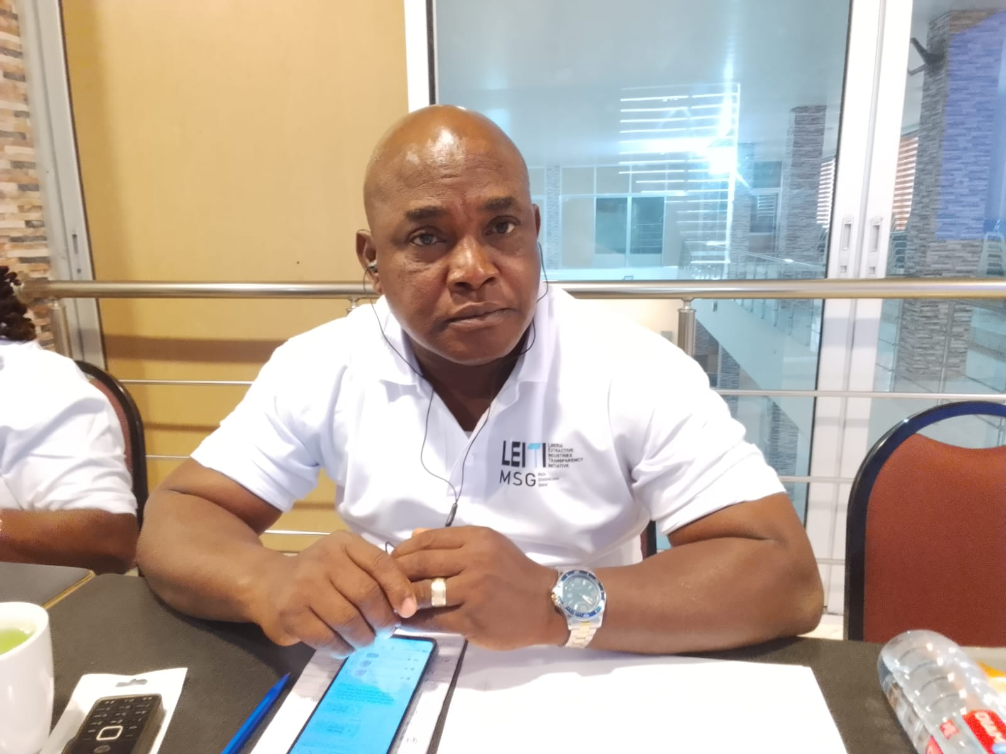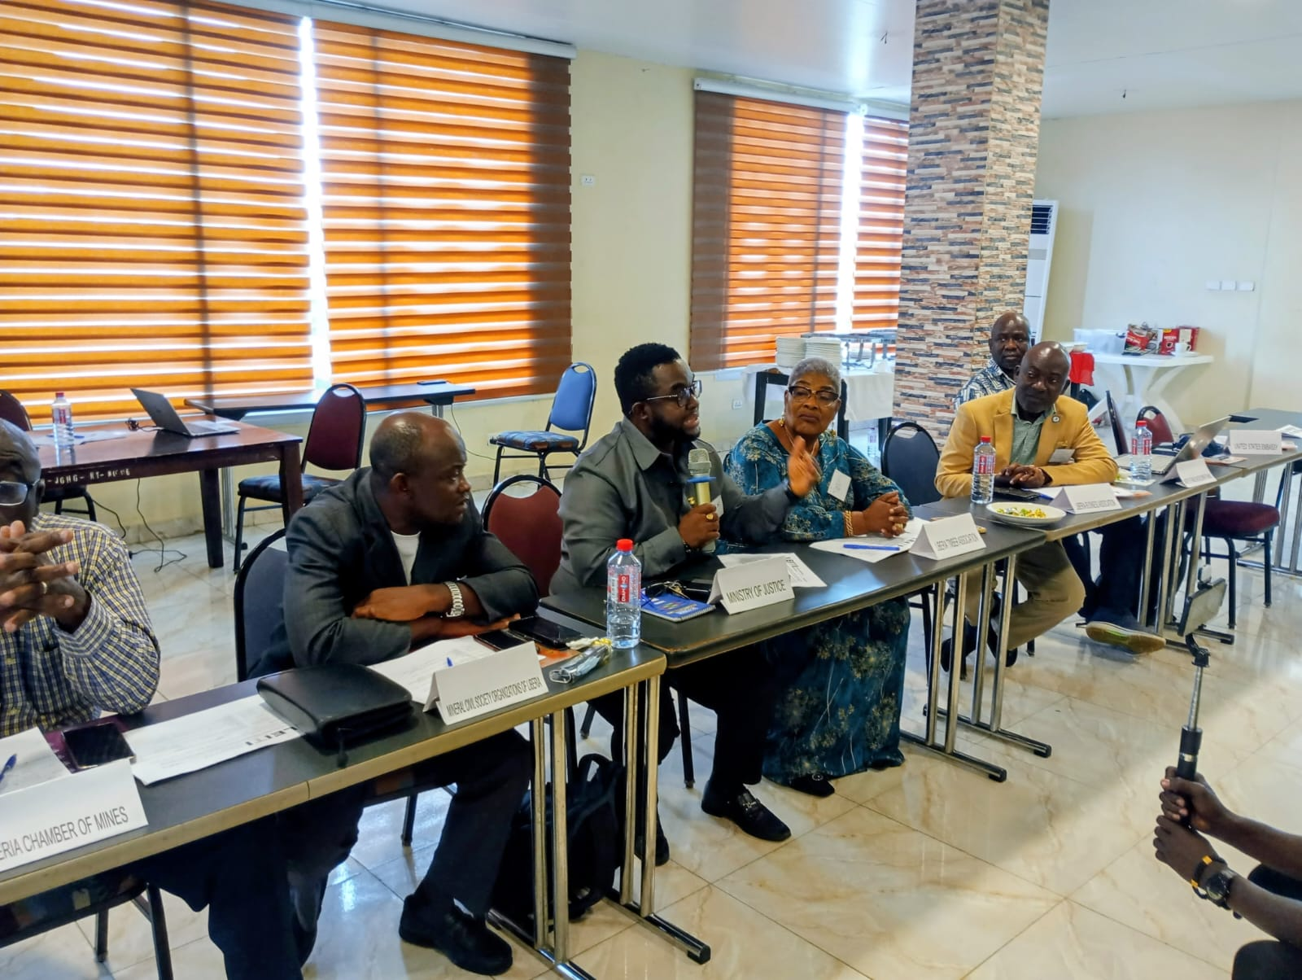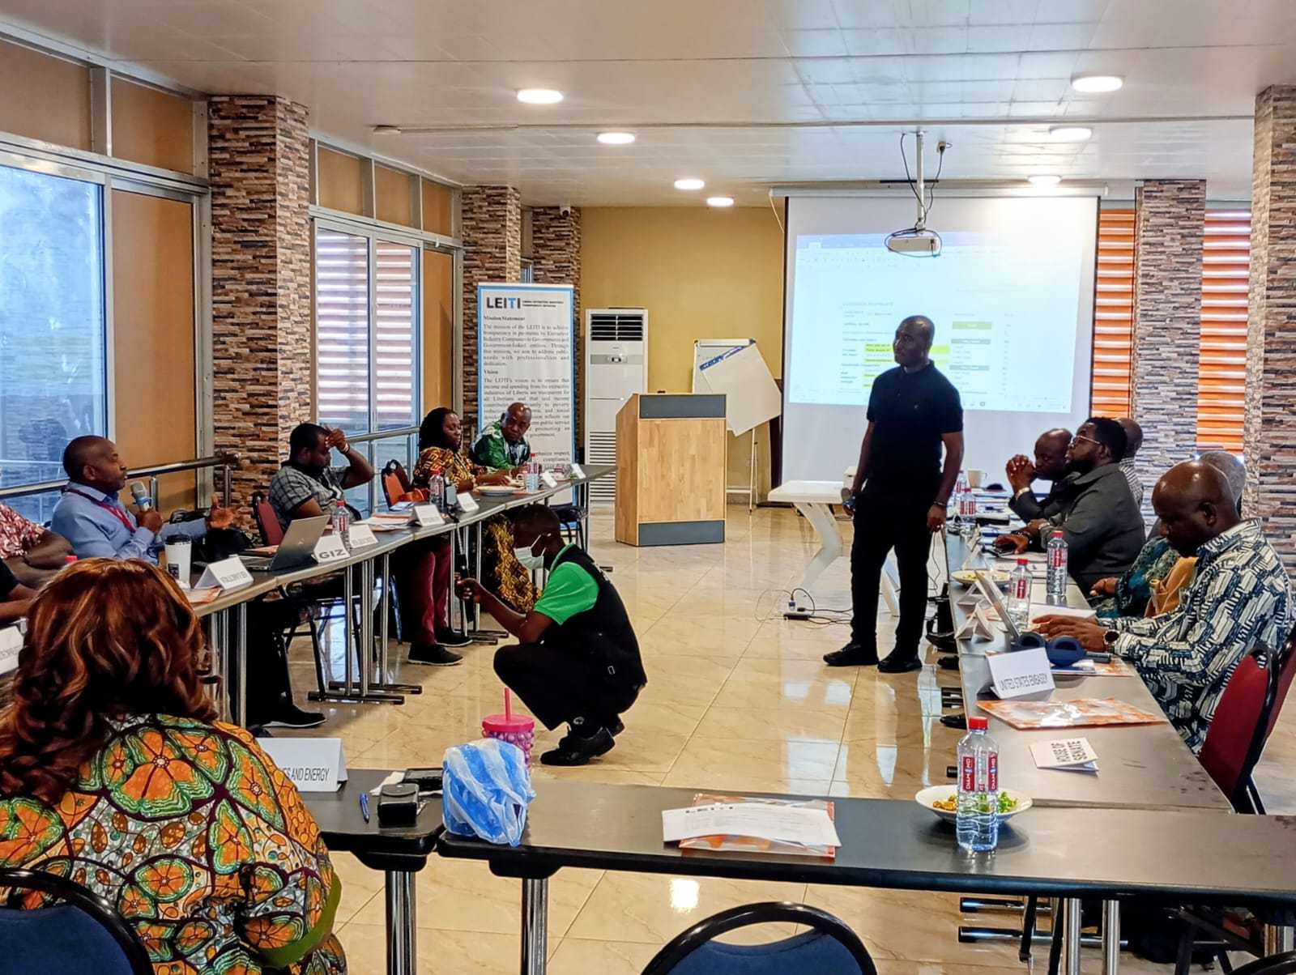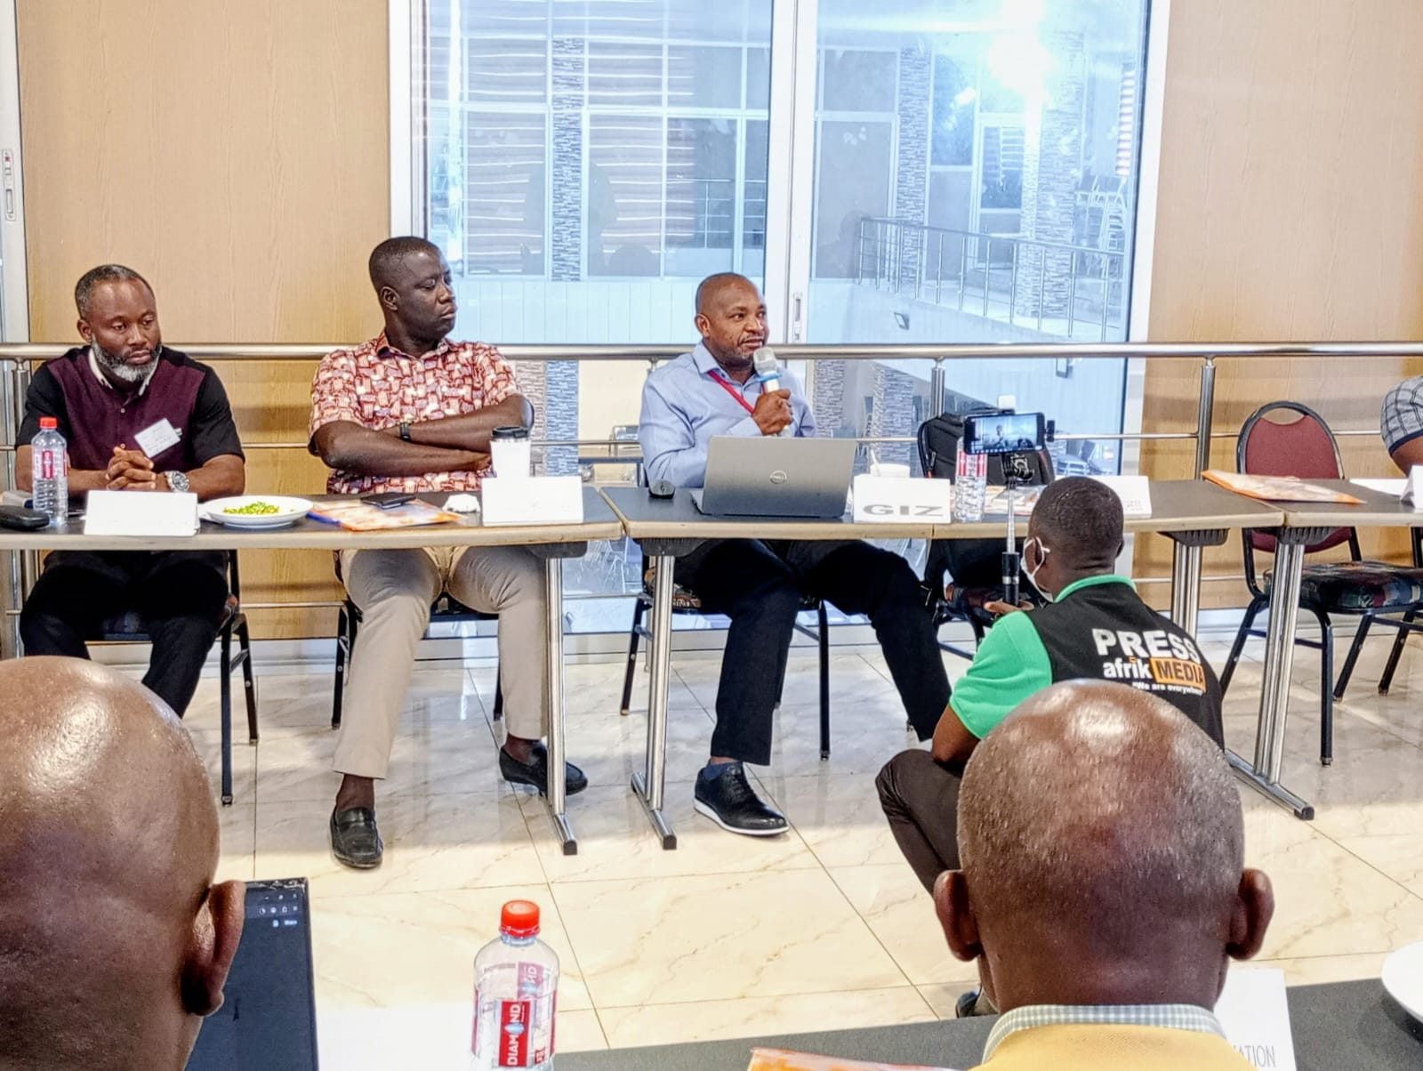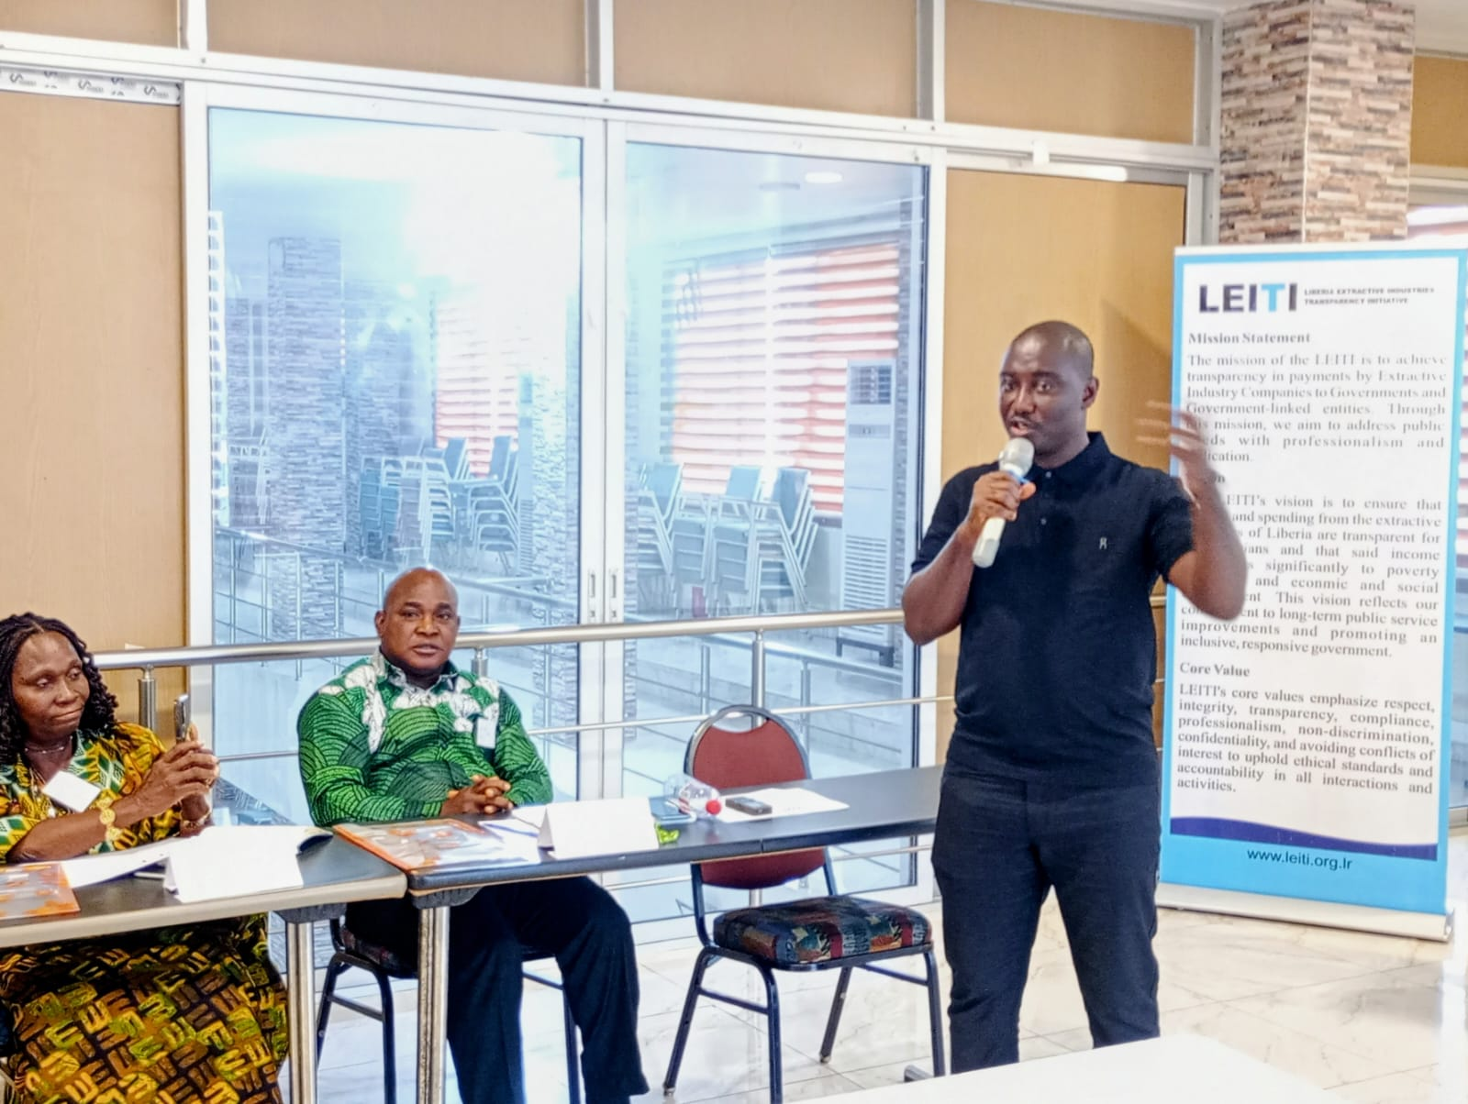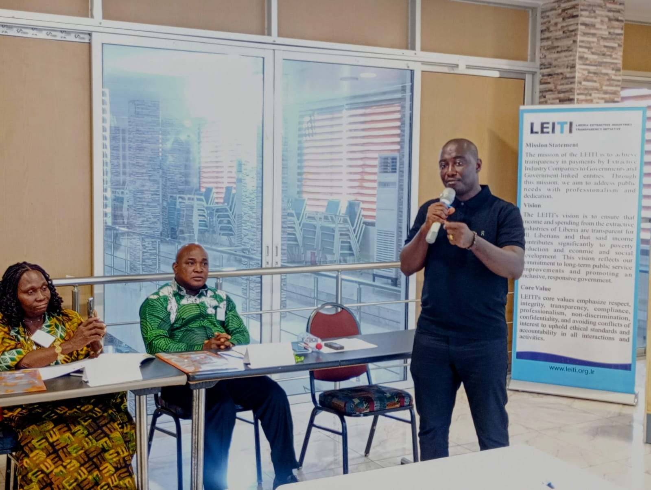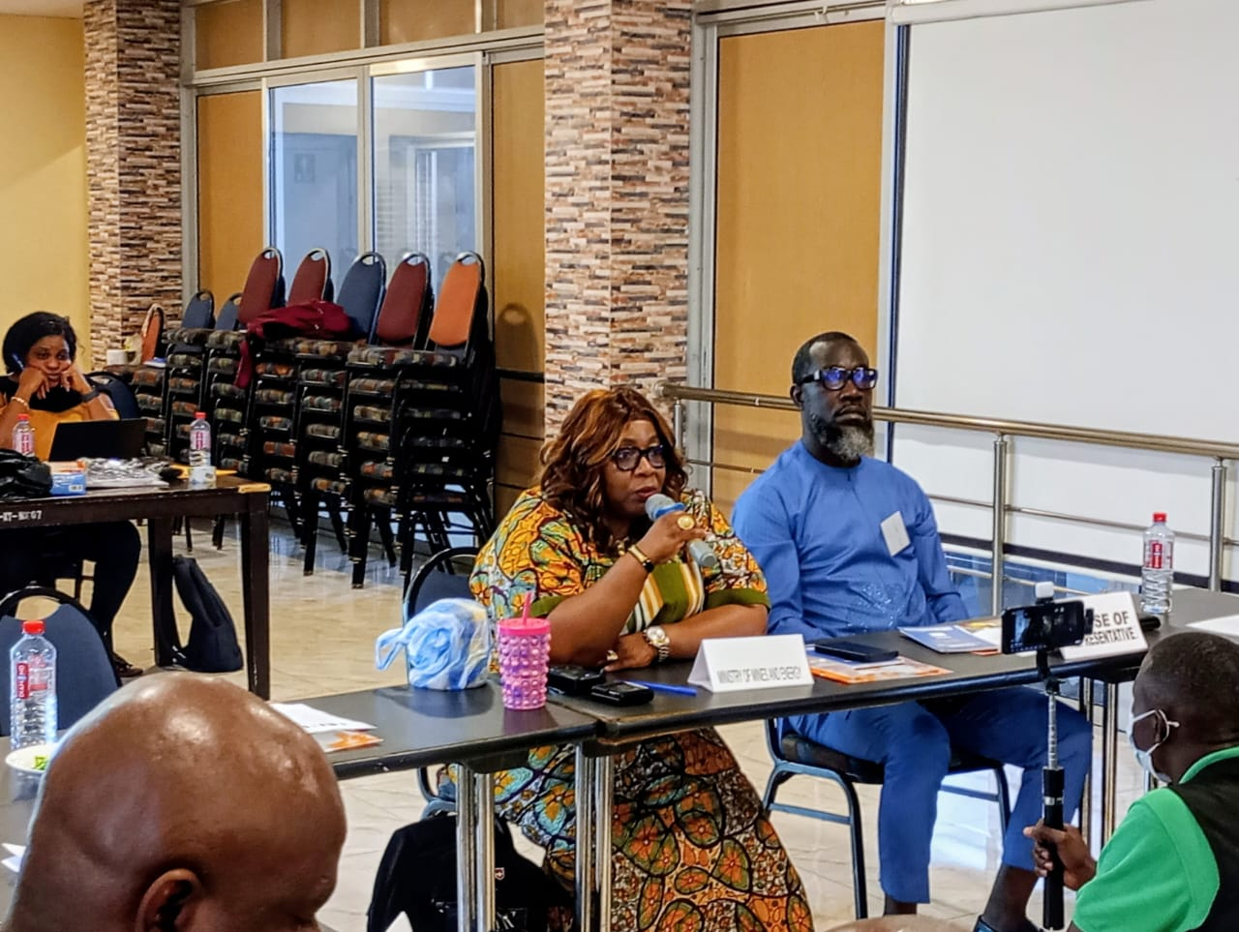
Cllr. J. Alben Greaves of the MOJ making a statement during discussions on the Draft Validation Report during the retreat.
MSG Member Ambassador George N. Kingsley of the National Civil Society Council of Liberia at the retreat.
Mr. Djomba Mara, GIZ-Liberia Project Manager, makes comments during a presentation on LEITI’s 2026 Dissemination Plan.
MSG members listen as Mr. Djomba makes his point during discussions on the draft MSG response to the Validation Team’s Draft Validation Report.

LEITI’s Head of Secretariat Jeffrey N. Yates making presentation on the 16th EITI Report summary.
Deputy Minister Eudora Blay-Pritchard making a point during the MSG retreat.

